Therapeutic Vaccination with pNGL4aCRTE6E7L2 and Electroporation for the Elimination of HPV16+ High Grade Anogenital Dysplasia

Kimberly Levinson, Johns Hopkins (JH), Baltimore, MD, USA; Rebecca Arend, University of Alabama (UAB), Birmingham, AL, USA; Tullia Rushton, JH, Baltimore, MD, USA; Peter Ketch, UAB, Birmingham, AL, USA; Benjamin Matthews, JH, Baltimore, MD, USA; Teresa Boitano, UAB, Birmingham, AL, USA; Hao Wang, JH, Baltimore, MD, USA; Sejong Bae, UAB, Birmingham, AL, USA; Darin Ostrander, JH, Baltimore, MD, USA; Karen Horner, JH, Baltimore, MD, USA; Ashish Solanki, JH, Baltimore, MD, USA; Alexis Peay, JH, Baltimore, MD, USA; Anna Wilbanks, UAB, Birmingham, AL, USA; Adrian Harsono, UAB, Birmingham, AL, USA Chien-Fu Hung, JH, Baltimore, MD, USA; Yachea Tsai, JH, Baltimore, MD, USA; Bailee Dover, UAB, Birmingham, AL, USA; Jennah Moore, UAB, Birmingham, AL, USA; Katelyn Kincaid, UAB, Birmingham, AL, USA; Donna Dunn, UAB, Birmingham, AL, USA; Charles Leath, UAB, Birmingham, AL, USA; TC Wu, JH, Baltimore, MD, USA; Warner Huh, UAB, Birmingham, AL, USA; Richard Roden, JH, Baltimore, MD, USA.

Objectives: To evaluate the safety and tolerability of a novel therapeutic DNA vaccine targeting HPV16 E6, E7 and L2 when delivered intramuscularly followed by electroporation, and its effects on histology and viral clearance.
Methods: pNGVL4aCRTE6E7L2 plasmid is administered intramuscularly with TriGrid electroporation in two dose finding cohorts: HIV- women with HPV16+ CIN2/3, and women living with HIV and HPV16+ CIN2/3, VIN2/3 or VAIN2/3. Vaccine is administered at weeks 0, 4, and 8 at 0.3mg, 1.0mg, or 3.0mg. All patients undergo LEEP excision at 6 months and are followed for 24 months. HPV16 is evaluated by Cobas swabs and RNAscope in histology.
Results: To date, 16 women have enrolled and 13 completed their 6-month evaluation (3 women living with HIV and 10 HIV- women). Only grade 1 toxicities were noted, and all self-resolved within 1 week. Discomfort at the injection site was the most common side effect.
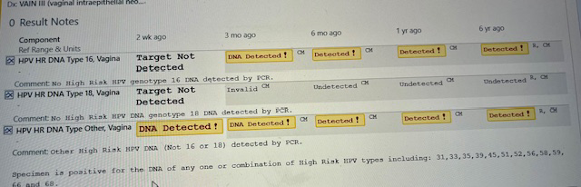
In the HIV- cohort, 7 of 10 women had resolution of high-grade dysplasia and converted to HPV16- by the 6 month visit. Three of 5 patients who were positive for other HR HPV types also cleared the other HR HPV by 6 months. All patients who completed their 12 month visit (8 patients) remained negative for HPV16.
Two of 3 patients living with HIV cleared their HPV16+ dysplasia (CIN3 and VAIN3), while 1 patient did not clear their HPV16+ VIN2/3. Both patients who cleared HPV16 had a longstanding history of HPV16 (>20 months positive and 6 years positive). Conversion to HPV16- at month 6 was confirmed by both PCR and in situ hybridization.
Conclusions: 3 mg of DNA vaccine delivered via electroporation is safe and well-tolerated. Early data suggest robust efficacy in HIV- patients with HPV16+ CIN2/3, with some clearance of other HR HPV types, as well as potential for activity in women living with HIV.

