Artificial intelligence for pre-operative assessment of
adnexal lesions from ultrasound images

Heather M. Whitney; Hui Li; Maryellen Giger
Department of Radiology, University of Chicago, Chicago, IL USA
Roni Yoeli-Bik; Jacques S. Abramowicz; Ryan E. Longman; Ernst Lengyel
Department of Obstetrics and Gynecology, University of Chicago, Chicago, IL USA
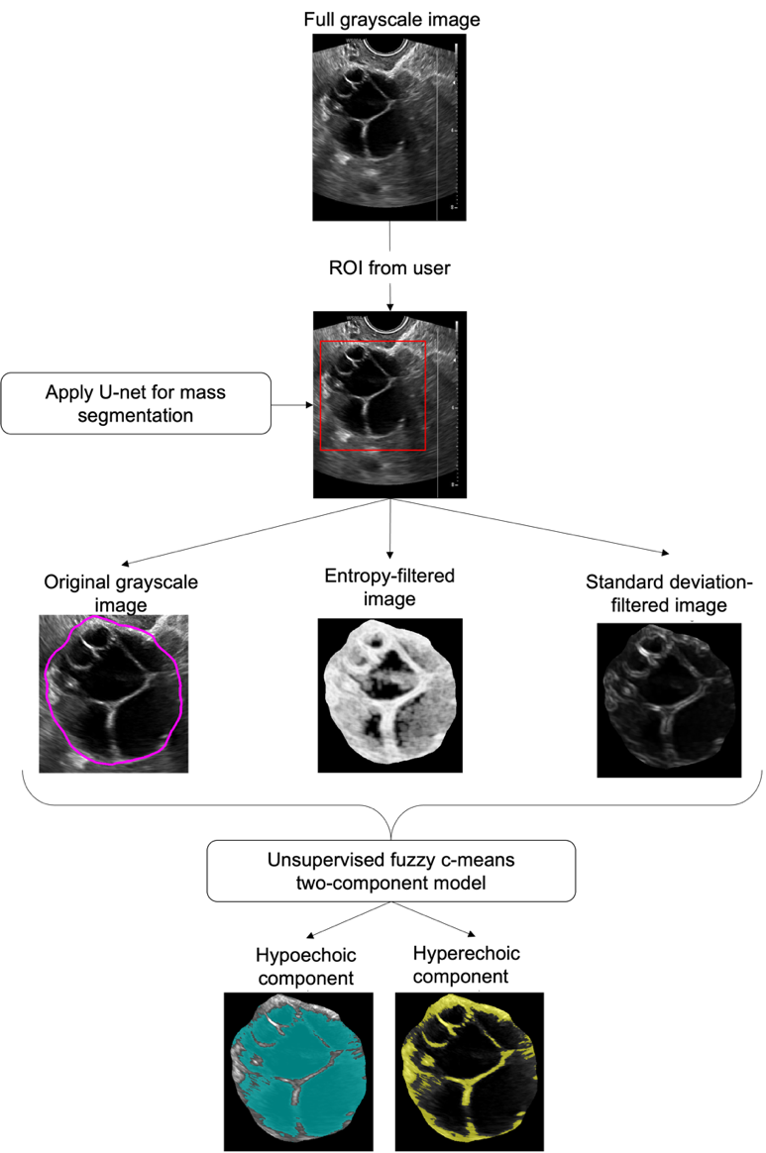
Figure 1: Example adnexal lesion segmented from background and separated into echogenic components.
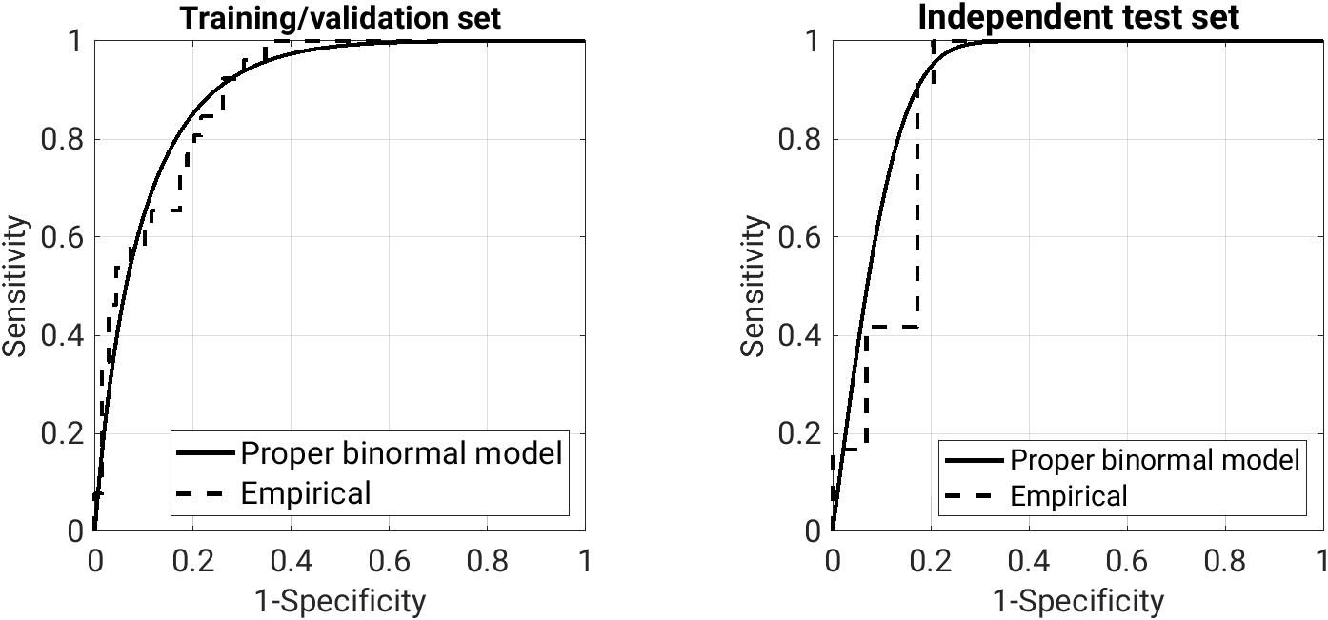
Figure 2: Receiver operating characteristic curve (task: distinguishing between malignant and benign adnexal lesions, using radiomic features)

Accurate, timely diagnosis of adnexal lesions as malignant or benign is important because malignancies require removal and treatment while unnecessary surgery can result in serious reproductive health morbidity. The overall purpose of our work is to develop an artificial intelligence/computer-aided diagnosis system (AI/CADx) for ultrasound imaging that can enhance decision-making support to medical providers, reducing the number of false-positive (missed cancers) and false-negative (unnecessary surgeries) in ovarian cancer medical care. We developed an AI/CADx pipeline for automatic segmentation, echogenic component-based radiomic feature extraction, and classification of adnexal lesions on ultrasound, requiring the user to only outline a box around the lesion of interest. The retrospective dataset of ultrasound images of adnexal lesions (1 per case, no markups; cancer prevalence 27.9%) was split into classification training/validation (95 lesions; 70%) and independent test sets (41 lesions; 30%). A portion of the training/validation set (54 lesions) was used for segmentation development (38 lesions) and evaluation (16 lesions). A supervised U-net was trained using expert outlines and evaluated using the Dice coefficient and the ratio of the Hausdorff distance to the effective diameter of the lesions (R_{HD-D}). An unsupervised fuzzy c-means algorithm was used to identify relative high and low echogenic components of the lesions (Figure 1). Eight echogenic component-based radiomic features were merged with solid elements to train a classifier to distinguish between malignant and benign lesions. The area under the receiver operating characteristic curve (AUC) in the test set was obtained by randomly sampling output 2000 times with replacement, using the proper binormal model. Sensitivity and specificity were evaluated at target 95% sensitivity. The Dice coefficient (median [95% confidence interval]) was 0.91 [0.78, 0.96] and R_{HD-D} was 0.04 [0.01, 0.12] in the segmentation evaluation set, indicating strong agreement with expert outlines. The AUC was 0.91 [0.83, 0.98] in the test set (Figure 2). At target 95% sensitivity, the sensitivity and specificity in the test set were 0.99 [0.87, 1.00] and 0.71 [0.54, 0.83], respectively. These results provide the foundation for future validation with images acquired external to our institution and for studies of clinician use of the tool, essential steps towards translation of the system for clinical use.

