VIRTUAL POSTER PRESENTION FORMATING INSTRUCTIONS

The Virtual Poster will be presented as pre-recorded PowerPoint presentation, allowing you to walk the viewer through the slides. Please limit the presentation to 15 minutes.

How to Record on PowerPoint:
- Microsoft PowerPoint: Record a Presentation Video: Watch a short video here.
- Select Slide Show > Record Slide Show.
- When you are ready, select Record and start speaking.
  - Note: PowerPoint does not record audio or video during transitions between slides, so be careful to not speak while advancing the slide. Include a brief buffer of silence before advancing to the next slide, and pause after advancing, to make the transitions smooth and ensure that you do not cut off audible narration.
- The slide show opens in the Recording window, which looks similar to Presenter view. There are buttons at the top left for starting, pausing, and stopping the recording. Click the round, red button when you are ready to start the recording. A three-second countdown ensues, then the recording begins.

- The current slide is shown in the main pane of the Recording window (see image immediately above). You will be able to display speaker notes near the top of the screen (near most built-in webcams). These notes will only be visible to the presenter.
- You can pause or stop your recording any time by pressing the pause or stop button on the screen.
- Navigation arrows on either side of the current slide allow you to move to the previous and next slides.
- PowerPoint for Microsoft 365 automatically records the time you spend on each slide, including any animated text steps that occur, and the use of any prompt on each slide.
- You can record audio or video narration as you record your presentation. The buttons at the lower-right corner of the window allow you to toggle on or off the microphone, camera, and camera preview:
- If you use the pen, highlighter, or eraser, PowerPoint records those actions for playback also.
- If you re-record your narration (including audio and ink), PowerPoint erases your previously recorded narration (including audio and ink) before you start recording again on the same slide.
  - NOTE: Your camera will be on during your recording, and there will be a box showing your video on the bottom right corner (see sample image above). Keep this in mind when designing your PowerPoint slides by keeping objects and text out of this region of the slides.
- If you would like to re-record a slide, you can select Slide Show > Record Slide Show > Clear > Clear Narration on Current Slide. See image immediately below.
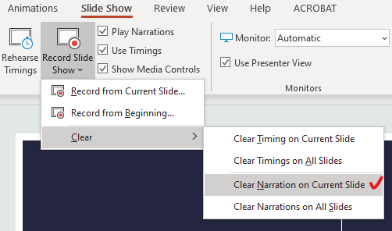

- All done? Preview your presentation and make sure it looks good and is within the time limit you have been assigned to speak. If you have gone over that time length, eliminate some of your words and re-record relevant slides to shorten the time length of your presentation.
- Export your presentation as an mp4: Select File > Export > Create a Video, then select Full HD (1080p) > Use Recorded Timing and Narrations > Create Video

