Inaugural NIH Annual Asian American, Native Hawaiian, and Pacific Islander
Health Research Conference

May 4-5, 2022
Virtual
https://events.cancer.gov/nih/AANHPI-HSIG-Annual-Conference/agenda

Host: NIH Asian American, Native Hawaiian, and Pacific Islander Health Scientific Interest Group
https://oir.nih.gov/sigs/AAPI-HSIG

Sponsor: National Cancer Institute, NIH
Co-sponsor: National Institute on Minority Health and Health Disparities, NIH

Objectives:
- Celebrate and provide education during the month of May on AANHPI heritage.
- Highlight research achievements in the population.
- Address research needs to provide recommendations for developing NIH's AA and NHPI research priority plan to NIH leadership (including the areas in RFI, NOT-CA-22-047 https://grants.nih.gov/grants/guide/notice-files/NOT-CA-22-047.html )
For further information or questions about the conference, please contact:
Dan Xi, PhD (xida@mail.nih.gov), Chair, NIH AANHPI-HSIG
*The Planning Committee:
Participating National Institutes of Health Institutes and HHS Agencies:
- NCI
- NIH OD
- NEI
- NHGRI
- NHLBI
- NIA
- NIDDK
- NIGMS
- NIMHD
- NINR
- CDC/HHS
- FDA/HHS
- HRSA/HHS
- OASH/HHS
- WHIAANHPI/HHS
- Others
**Additional Others Participating in Training:
- NCI Integrative Medicine Cancer Disparity Working Group (co-host of conference)
- NIH Program Officers
- NIH AANHPI-HSIG
- NIH FAN
- FAPAC NIH Chapter

Table of Contents
Leadership Opening Remarks 3
Keynote Speakers 6
Speakers 8

LEADERSHIP OPENING REMARKS

Dr. Lawrence Tabak, Acting Director, NIH
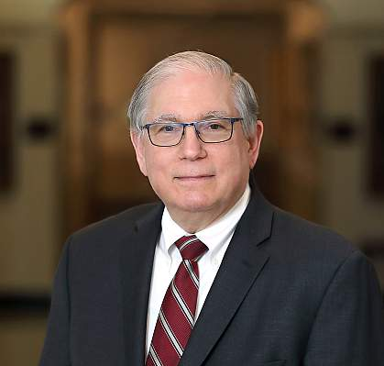
Lawrence A. Tabak, D.D.S., Ph.D., is the Acting Director of the National Institutes of Health (NIH), officially taking office on December 20, 2021. Dr. Tabak has served as the Principal Deputy Director and the Deputy Ethics Counselor of NIH since August 2010. He previously served as the Acting Principal Deputy Director of NIH (2009), and prior to that as Director of the National Institute of Dental and Craniofacial Research from 2000–10. Prior to joining NIH, Dr. Tabak was the Senior Associate Dean for Research and Professor of Dentistry and Biochemistry & Biophysics in the School of Medicine and Dentistry at the University of Rochester in New York. A former NIH MERIT recipient, Dr. Tabak's major research focus has been on the structure, biosynthesis, and function of glycoproteins. He continues work in this area, maintaining an active research laboratory within the NIH intramural program in addition to his administrative duties. Dr. Tabak is an elected member the National Academy of Medicine (formerly IOM) of the National Academies. He received his undergraduate degree from City College of New York, his D.D.S. from Columbia University, and a Ph.D. from the University of Buffalo.
Dr. Eliseo Pérez-Stable, Director, NIMHD
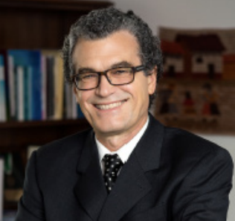
Dr. Eliseo Pérez-Stable is Director of the National Institute on Minority Health and Health Disparities (NIMHD) at the National Institutes of Health (NIH). He earned his B.A. in chemistry in 1974 and M.D. in 1978 from the University of Miami. He then completed his primary care internal medicine residency and a research fellowship in general internal medicine at University of California, San Francisco (UCSF) before joining the faculty as an assistant professor in 1983. Dr. Pérez-Stable practiced primary care internal medicine for 37 years at UCSF following a panel of about 200 patients and supervised and taught students and residents in the ambulatory care and hospital settings. Dr. Pérez-Stable’s research interests have centered on improving the health of racial and ethnic minorities through effective prevention interventions, understanding underlying causes of health disparities, and advancing patient-centered care for underserved populations. Recognized as a leader in Latino health care and disparities research, he spent 32 years leading research on smoking cessation and tobacco control in Latino populations in the United States and Latin America, addressing clinical and prevention issues in cancer control research, supporting early career scientists in research on minority aging in clinical and community settings, and addressing research questions in clinical conditions such as hypertension, asthma, diabetes and dementia. He has published more than 300 peer-reviewed papers and was continuously funded by NIH grants for 30 years prior to becoming NIMHD Director. Dr. Pérez-Stable was elected to the National Academy of Medicine (formerly Institute of Medicine) of the National Academy of Science in 2001 and the American Society of Clinical Investigation in 1996.

Ms. Krystal Ka‘ai, Executive Officer, WHIAANHPI, HHS
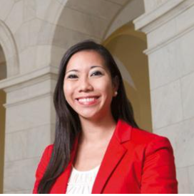
Krystal Ka‘ai is the Executive Director of the White House Initiative on Asian Americans, Native Hawaiians, and Pacific Islanders (WHIAANHPI) and the President’s Advisory Commission on Asian Americans, Native Hawaiians, and Pacific Islanders. In this role, she is responsible for advising the Biden administration on the coordination and implementation of federal programs and initiatives to advance equity, justice, and opportunity for Asian American, Native Hawaiian, and Pacific Islander (AA and NHPI) communities. Prior to joining WHIAANHPI, Krystal worked on Capitol Hill for over a decade, including serving as the Executive Director of the Congressional Asian Pacific American Caucus (CAPAC) for eight years. She previously held positions with the U.S. Senate Committee on Indian Affairs, the State of Hawai‘i, Office of Hawaiian Affairs, and the National Japanese American Memorial Foundation. Krystal was born and raised in Hawai‘i and is the first Native Hawaiian to ever lead WHIAANHPI.
Ms. Erika L. Moritsugu, Deputy Assistant to the President AA and NHPI Senior Liaison
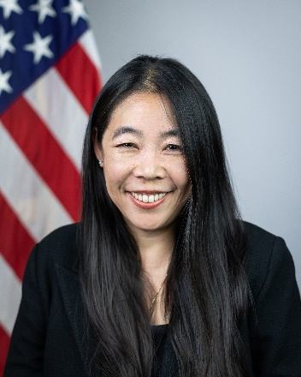
Erika was appointed by President Joe Biden in April 2021 to serve as Deputy Assistant to the President and AA and NHPI Senior Liaison. At the White House, Erika supports the Administration on the full array of the President’s priorities and engages with AA and NHPI communities and leaders on important issues such as advancing safety, justice, inclusion, and opportunity for Asian American, Native Hawaiian, and Pacific Islander communities through a whole-of-government approach to racial justice and equity. Her past government service includes serving as the Assistant Secretary for Congressional and Intergovernmental Relations at the Department of Housing and Urban Development under the leadership of Secretary Julián Castro in the Obama Administration and was the first-ever Senate Deputy Legislative Director at the Consumer Financial Protection Bureau. On Capitol Hill, she was a senior representative of Senator Tammy Duckworth of Illinois, Senator Daniel K. Akaka of Hawai‘i, and at the Senate Democratic Policy Committee under Senate Majority Leader Harry Reid of Nevada. In the non-profit sector, Erika managed two teams the National Partnership for Women & Families for economic justice and congressional relations advancing workforce and health policies focused through a gender equity and race equity lens. Erika has also led the Government Relations, Advocacy and Community Engagement team at the Anti-Defamation League, which included leading its interreligious and interfaith work.
Dr. Marie Bernard, Chief Officer for Scientific Workforce Diversity, and Co-Chair, UNITE, NIH
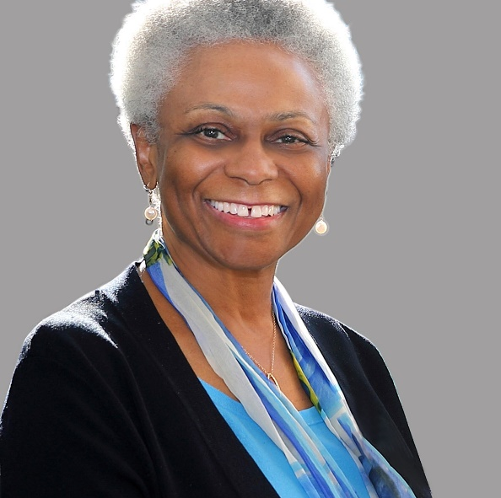
Dr. Marie Bernard, the Chief Officer for Workforce Diversity at NIH. She is also a Co-Lead of the NIH UNITE initiative to end structural racism. Since assuming this position Dr. Bernard has been instrumental in establishing and Co-chairing several NIH committees with focus on promoting diversity throughout all of NIH and the greater scientific community in general through recruiting, retaining, and promoting people from diverse backgrounds. Prior to joining this office, she was the Deputy Director of the National Institute on Aging, where together with Director she oversaw a budget of more than $3 billion dollars, helped develop several new initiatives specially related to people with Alzheimer’s disease and related Dementias. At NIA, she was also overseeing the Office of Special Populations whose focus is on training scientists from diverse backgrounds on Health disparities research. Being a Geriatrician by profession, Dr. Bernard had special affinity for improving the life of older populations, particularly underrepresented racial and ethnic populations. She has served on several national committees, including as chair of the Clinical Medicine Section of the Gerontological Society of America, chair of the Department of Veterans Affairs National Research Advisory Committee, board member of the American Geriatrics Society, and president of the Academy for Gerontology in Higher Education. Before joining NIH, she was an endowed Professor and founding chair of the Reynolds Department of Geriatric Medicine at the University of Oklahoma College of Medicine. Dr. Bernard was an undergraduate of Bryn Mawr College, and she received her medical degree from University of Pennsylvania.
Dr. Katrina Goddard, Director, DCCPS, NCI
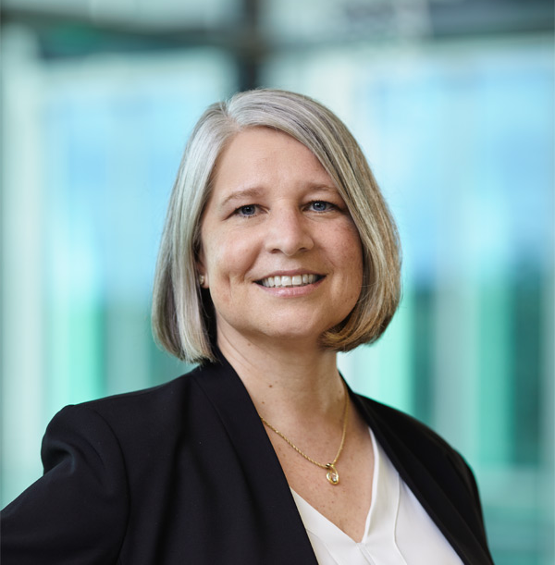
Dr. Katrina Goddard was appointed Director of the Division of Cancer Control and Population Sciences (DCCPS) in October 2021. In this position, she oversees a division that covers a wide range of scientific domains and disciplines, including epidemiology, behavioral science, surveillance and statistics, cancer survivorship, and health services and outcomes research. Prior to joining NCI, Dr. Goddard was a Distinguished Investigator and Director of Translational and Applied Genomics at the Kaiser Permanente Center for Health Research (CHR) in Portland, OR. Dr. Goddard is a genetic epidemiologist who focuses on public health genomics and the translation of genomic applications into clinical practice. She has directed or collaborated on over 25 federally funded research studies and has held numerous leadership positions on national research consortia. Dr. Goddard has also contributed to knowledge synthesis products that have far-reaching impact for numerous national organizations. She has played key roles in the NIH-funded ClinGen Consortium, directing its Knowledge Synthesis Team—which provides systematic evidence summaries on the ClinGen website for the entire genomics community—and co-chaired the Actionability Working Group. She has served on the board of directors of both the American Society of Human Genetics and the International Genetic Epidemiology Society. Dr. Goddard received her Ph.D. in biostatistics from the University of Washington and a BS in molecular biology from the University of Wisconsin-Madison.

KEYNOTE SPEAKERS

Dr. Victor Dzau, President, National Academy of Medicine
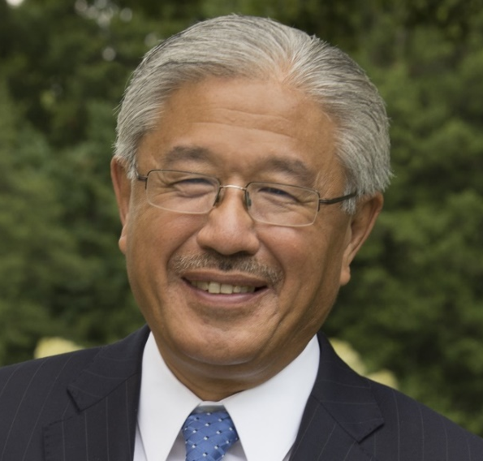
Victor J. Dzau, M.D., is the President of the US National Academy of Medicine (NAM), and serves as Vice Chair of the US National Research Council. Professor Dzau is Chancellor Emeritus of the Duke University. Previously, he was Chairman of Medicine at Harvard, as well as Stanford Universities. Professor Dzau is highly regarded as a trailblazer in translational research, health innovation, and global health. His seminal work laid the foundation for development of lifesaving drugs known as ACE inhibitors, used globally to treat hypertension and heart failure. Professor Dzau pioneered gene therapy for vascular disease. As one of the world’s preeminent health leaders, he has served as Chair of the NIH Cardiovascular Disease Advisory Committee and now chairs the NIH Cardiovascular Stem Cell Consortium. Currently he chairs the International Scientific Committee of the Qatar Genome Project and is a member of Health Biomedical Sciences Advisory Council of Singapore. He was on the Board of Health Governors of the World Economic Forum and chairs its Council on Human Longevity and Enhancement. Professor Dzau is active in Global Heath. He founded the Duke Global Health Institute, Duke NUS medical school in Singapore and the Division of Global Health Equity at Harvard. He served on the interim board of CEPI. Leading the National Academy of Medicine, Professor Dzau has launched important initiatives such as the Global Health Risk Framework (2016), the Global Health and the Future Role of the US (2017), Integrating Clinical Research into Epidemic Response: The Ebola Experience (2017); Crossing the Global Quality Chasm (2018), Human Gene Editing (2017) and the NAM Grand Challenge in Healthy Longevity.
Dr. Howard Koh, Professor, Harvard T.H. Chan School of Public Health
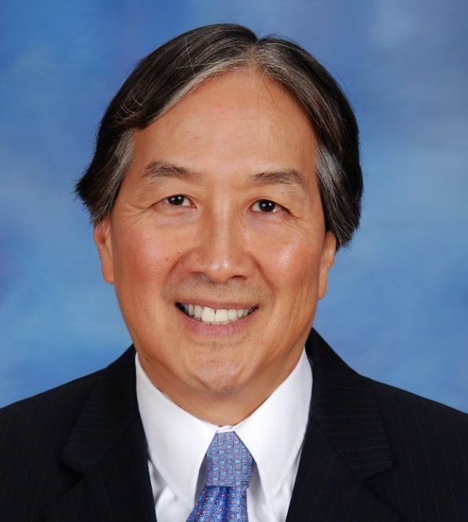
Dr. Howard K. Koh is the Harvey V. Fineberg Professor of the Practice of Public Health Leadership at the Harvard T. H. Chan School of Public Health and the Harvard Kennedy School as well as Faculty Co-Chair of the Harvard Advanced Leadership Initiative. Since 2014, in these roles, he advances interdisciplinary leadership education and training at the Harvard T.H. Chan School of Public Health as well as across Harvard University. He also serves as the inaugural Chair of the Harvard T. H. Chan School of Public Health Initiative on Health and Homelessness and Co-Director of the Initiative on Health, Spirituality and Religion at Harvard University. Previously at Harvard School of Public Health (2003-2009), he was Associate Dean for Public Health Practice and Director of the School’s Center for Public Health Preparedness. From 2009-2014, Dr. Koh was the 14th Assistant Secretary for Health for the U.S. Department of Health and Human Services (HHS), after being nominated by President Barack Obama and being confirmed by the U.S. Senate. In his academic career, Dr. Koh has been Principal Investigator (PI) for over $25 million in research grant activities and is currently the PI of the Robert Wood Johnson Foundation– funded grant “Making a Culture of Health a Business Leadership Imperative.” From 1997-2003, Dr. Koh was Commissioner of Public Health for the Commonwealth of Massachusetts after being appointed by Governor William Weld. As Commissioner, he led the Massachusetts Department of Public Health, which included a wide range of health services, four hospitals, and more than 3,000 health professionals. Dr. Koh graduated from Yale College, where he was President of the Yale Glee Club, and the Yale University School of Medicine. He completed postgraduate training at Boston City Hospital and Massachusetts General Hospital, serving as chief resident in both hospitals. He has earned board certification in four medical fields: internal medicine, hematology, medical oncology, and dermatology, as well as a Master of Public Health degree from Boston University. At Boston University Schools of Medicine and Public Health, he was Professor of Dermatology, Medicine and Public Health as well as Director of Cancer Prevention and Control.

SPEAKER BIOGRAPHIES

Dr. Shugeng Cao, Professor, University of Hawai’i at Hilo
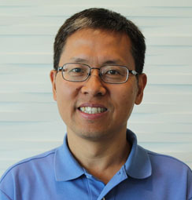
Dr. Shugeng Cao has worked with naturally derived compounds since his time as a graduate student. While at the National University of Singapore, he did his doctoral research on tropical plants collected from the island of Borneo in Southeast Asia. After his doctoral studies, he joined the MerLion Pharmaceuticals where he studied biologically active compounds derived from bacteria, fungi, plant, and marine organisms. From there Dr. Cao went on to join the Kingston Group at Virginia Tech where he conducted assay-guided separation of compounds from tropical plants and marine organisms collected in Surinam and Madagascar. His research led him to Harvard Medical School where he was hired in 2008 as the director of the Marcus Natural Product Lab under Dr. Jon Clardy. In 2013, Cao was invited to work as an independent researcher at the University of Hawai’i Cancer Center. He worked at the center for two years before transferring to UH Hilo’s Daniel K. Inouye College of Pharmacy in 2015 where he has contributed greatly to UH Hilo. In 2021, he received both a promotion to full professor and the annual Chancellor’s Award for Excellence in Scholarly/Creative Activities at the 2021 awards celebration. His current research focuses on discovery of biologically active compounds from natural sources including Hawaiian fungi and bacteria, herbal medicine including Hawaiian traditional medicine, and small molecules with functions in human and animal. So far, Dr. Cao has published 160 papers in peer-reviewed journals.

Dr. Moon Chen, Professor, University of California, Davis
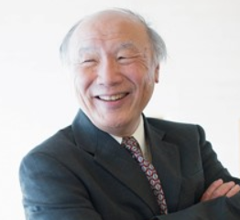
Moon S. Chen Jr., PhD, MPH, University of California, Davis is a Professor in the Division of Hematology and Oncology and the Associate Director for Community Outreach/Engagement for the UC Davis Comprehensive Cancer Center. He is a behavioral scientist with over 30 years of experience in conducting health behavior intervention research, having spent more than two decades as a NCI-funded Center to Reduce Cancer Health Disparities PI conducting research to mitigate cancer health disparities in various racial/ethnic populations including being the founding PI for the NCI-funded National Center for Reducing Asian American Cancer Health Disparities. (U54CA153499) as well as being the PI of “Liver Cancer Control Interventions for Asian Americans” (P01CA109091-A1). His awards for leadership have been recognized by the American Cancer Society (National) as a recipient of the Humanitarian Award; National Center on Minority Health & Health Disparities Leadership Award; Centers for Disease Control and Prevention; Hepatitis B United; and Ohio Commission on Minority Health. His presentation will be based on a 2022 JNCI Commentary, “Charting a Path Towards Asian American Cancer Health Equity: A Way Forward” co-authored with six other authors and being a multiple PI on a NIMHD R01, “Elucidating lung cancer etiology among Asian American female never smokers” (R01MD014859) with Drs. Scarlett Gomez and Iona Cheng and a NCI U54, University of California Minority Patient-Derived Xenograft (PDX) Development and Trial Center (U54 CA233306) with Drs. Luis Carvajal-Carmona and Chong Pan. This U54 is the only NCI-funded U54 that includes a focus on PDXs for Asian Americans.
Dr. Wei-Ti Chen, Associate Professor, University of California, Los Angeles
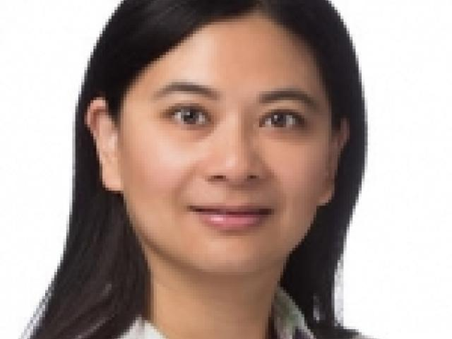
As a certified nurse-midwife and work with patients with sexually transmitted diseases, Dr. Wei-Ti Chen understands the complex issues in caring for Asian and Pacific. Since 2002, Dr. Chen have been involved in HIV-related projects in China, Taiwan, Myanmar, Thailand and the United States. Domestically, she works with local NGOs in HIV-related issues including substance use, aging, and patient-provider relationships in Asian and Pacific Americans in New York City, Los Angeles and San Francisco for more than 20 years. Globally, Dr. Chen have worked with Asia countries for their HIV Care where she has interacted with the China CDC, Taiwan CDC, Japan Juntendo University, ChiangMai University, Myanmar University of Nursing, Yangon, and several other institutions. She is familiar with the culture and value of Asian and Pacific American population. She has published more than 90 empirical papers on issues including substance use, domestic violence, self- and family-management and HIV care in the United States and several Asia countries. Many of her publications are using in-depth interviews with study participants to present their life stories and reflect their suggestions shape future intervention as well as RCT effectiveness to the HIV-infected population. Dr. Chen works with Asian Pacific Americans in her career and have an extensive network of contacts in the Asian and Pacific Americans especially in HIV self-and family-management intervention.

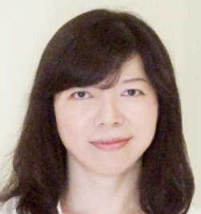
Dr. Yu-Ju Chen, Distinguished Research Fellow, Institute of Chemistry, Academia Sinica,
Taipei, Taiwan
Dr. Yu-Ju Chen obtained her B.S. in Chemistry from National Taiwan University (1992) and Ph.D. degree at Iowa State University. After postdoctoral research work at the Ames Laboratory, Department of Energy, USA and at National Tsing Hua University, Dr. Chen joined the Institute of Chemistry of Academia Sinica in 1999 and is currently a Distinguished Research Fellow (2019). She currently holds con-current adjunct professorships at few universities. With great passion to reveal disease network, Dr. Chen is one of the pioneering scientists in establishing mass spectrometry-based proteomics in Taiwan. Her research focuses on methodology development by integrating novel nanomaterial, advanced mass spectrometry and bioinformatics. In particular, she is interested in applying these tools for in-depth exploration of the under-represented membrane proteome and post-translational modificom and their application to delineate the proteome network in biology and diseases. Her work has been published in > 150 articles, including Cell, Cancer Cell, Plant Cell, Nat. Commun., PNAS, Mol. Cell. Proteomics. Proteomics, J Proteome Res., Anal. Chem., and JACS. She is acting as Associate Editor of “Analytical Chemistry”, Editorial Board of “Proteomics” and “Journal of Proteome Research”. She has been the President of the Taiwan Proteomics Society (2009-2011), President of Taiwan Society for Mass Spectrometry (2011-2013). She is also the Vice President (2017-2019) and Council Member of AOHUPO. She is now the President of Human Proteome Organization (HUPO, 2021-2022), and Vice President (President-elect) of The Chemical Society located in Taipei (2021-2022).
Dr. Anne Chiang, Associate Professor, Yale School of Medicine
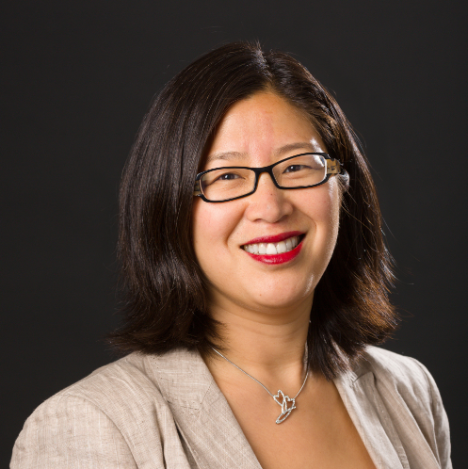
Anne Chiang, MD, PhD, currently serves as an Associate Professor of Medicine in the Section of Medical Oncology, specializing in thoracic oncology, with a background in translational research in metastasis, as well as extensive experience in clinical practice in both academic and community settings. Her clinical focus has been to build a small cell lung cancer program at Yale with a comprehensive portfolio of clinical trials testing novel therapeutics for these patients. Her research interests focus on development of clinical trials and translational studies to test novel agents and combinations with immune checkpoint inhibitors for both small cell and non-small cell lung tumors. In addition, she is the Deputy Chief Medical Officer and Chief Integration Officer for Smilow Cancer Hospital (SCH), having helped to build the SCH Network and oversee operations, quality efforts and clinical research in our Smilow Care Centers. She has a particular focus in quality measurement and improvement and has worked to achieve ASCO QOPI Certification for the entire Smilow academic clinical practice. She has spearheaded quality initiatives locally and nationally for ASCO and dedicated to quality improvement for patient-centered cancer services, and champion the use of patient-reported outcomes.

Dr. Michael Chiang, Director, NEI, NIH
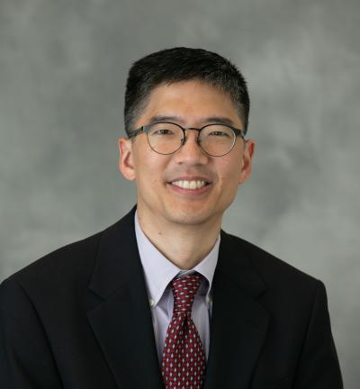
Michael F. Chiang is director of the National Eye Institute, at the National Institutes of Health in Bethesda, Maryland. His clinical practice focuses on pediatric ophthalmology and strabismus, and he is board-certified in clinical informatics. His research develops and applies biomedical informatics methods to clinical ophthalmology in areas such as retinopathy of prematurity (ROP), telehealth, artificial intelligence, clinical information systems, genotype-phenotype correlation, and data analytics. His group has published over 200 peer-reviewed papers, and has developed an assistive artificial intelligence system for ROP that received Breakthrough Status from the U.S. Food and Drug Administration. He received a BS in Electrical Engineering and Biology from Stanford University in 1991, an MD from Harvard Medical School and the Harvard-MIT Division of Health Sciences and Technology in 1996, and an MA in Biomedical Informatics from Columbia University. He completed residency and pediatric ophthalmology fellowship training at the Johns Hopkins Wilmer Eye Institute. Between 2001-2010, he worked at Columbia University, where he was Anne S. Cohen Associate Professor of Ophthalmology & Biomedical Informatics, director of medical student education in ophthalmology, and director of the introductory graduate student course in biomedical informatics. From 2010-2020, he was Knowles Professor of Ophthalmology & Medical Informatics and Clinical Epidemiology, and Associate Director of the Casey Eye Institute, at the Oregon Health & Science University (OHSU) Casey Eye Institute. He co-directed an NIH-funded T32 training program in visual science for graduate students and research fellows, as well as an NIH-funded K12 clinician-scientist program at OHSU.
Dr. Youping Deng, Professor, University of Hawai’i
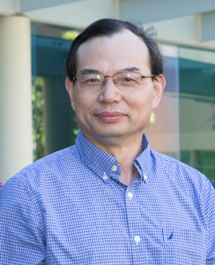
Youping Deng, PhD, is currently tenured full Professor, in the Department of Quantitative Health Sciences of the University of Hawaii John A. Burns School of Medicine. He currently serves as the Director of Bioinformatics Core at Hawaii INBRE. He is also the Co-Director of Genomics and Bioinformatics Shared Resource of University of Hawaii Cancer Center. Before joining University of Hawaii in 2016, he was Director of Bioinformatics and Biostatistics, Associate Professor at Rush University Medical Center. Dr. Deng is well trained in genomics, computer science, and bioinformatics. He has over 20 years of experience in bioinformatics data analysis and management. He has taught bioinformatics courses and trained bioinformatics PhD students and postdocs. He received his Ph.D. from Peking Union Medical College and finished his postdoctoral training at Wayne State University. He has published over 240 peer-reviewed articles with 2 active R01 grants.

Dr. Edwin Fisher, Professor, University of North Carolina
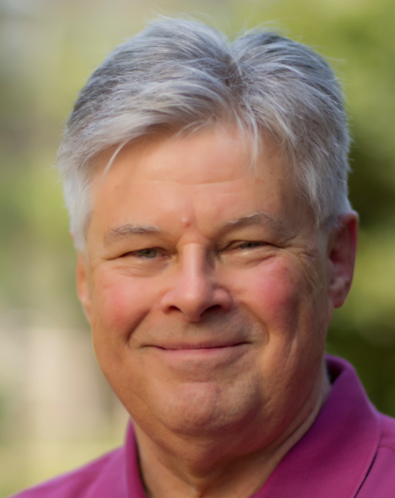
Edwin B. Fisher, Ph.D., is Professor in the Department of Health Behavior in the Gillings School of Global Public Health at the University of North Carolina at Chapel Hill. Prior to moving to UNC-CH in 2005, he was Professor in Medicine, Pediatrics and Psychology and Director of the Division of Health Behavior Research at Washington University in St. Louis. At Washington University, he also served as Associate Director for Prevention and Control of both the NIDDK-supported Diabetes Research and Training Center (1981-2005) and the NCI-supported Alvin J. Siteman Comprehensive Cancer Center (1995-2005). A clinical psychologist, he has served since 2008 as Global Director of Peers for Progress that promotes evidence, resources, and advocacy for peer support in health, health care, mental health and prevention around the world. Prior to that, he was National Program Director of the Robert Wood Johnson Foundation’s Diabetes Initiative (2002-2009) that examined self management of diabetes in primary care and community settings. He also co-directs the Community, Family and Peer Support research core of the Michigan Center for Diabetes Translational Research (2021-2026). His research has also addressed challenges in asthma, cancer, cardiovascular disease, mental health, smoking cessation, and weight management, focusing on community based approaches and social and peer support as well as self management. Among other honors, he is a past-president of the Society of Behavioral Medicine and principal editor of Principles of Behavioral Medicine: A Global Handbook (Springer, 2018).
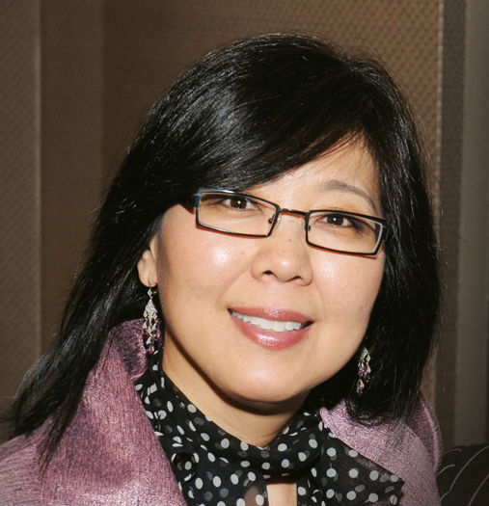
Dr. Karen Kim, Professor, The University of Chicago
Karen E. Kim, MD, MS., is Vice Provost for Research and Senior Research Officer at the University of Chicago, Professor of Medicine, and Associate Director of the University of Chicago Comprehensive Cancer Center. As Vice Provost for Research, Dr. Kim collaborates with divisions, schools, centers and institutes across the University to establish strategic research priorities, implementation strategies, and large-scale research infrastructure to increase research funding and broader impact. Dr. Kim established and directs the University of Chicago Center for Asian Health Equity, the only research center dedicated to the study of Asian health disparities in the Midwest. Under Dr. Kim’s leadership, this Center provides a unique and valuable national platform for advancing the health of Asian American communities through community-engaged health research, community engagement, training and policy strategies. As a nationally recognized leader in Asian health disparities, Dr. Kim’s research has contributed greatly to the knowledge base of the health of Asian American communities and the nuanced and complex factors influencing disparities across these diverse populations. In addition, Dr. Kim has been widely recognized for her leadership in advocacy/policy and civic engagement. She served on the NIH Advisory Committee, Office of Research for Women’s Health, received the BSD Distinguished Leader in Diversity and Inclusion Award, American Cancer Society Community Partnership Award, the Public Health Advocacy Award, the International Women’s Leadership award, the Chicago Foundation for Women Impact Award and the Cancer Prevention Laurel for Increasing Health Equity. Most importantly, as a daughter of Korean immigrants, a community advocate and a member of the Asian American community who has spent her entire life in Chicago and the Midwest, Dr. Kim has been a steadfast servant leader to give voice to those unable to do so.
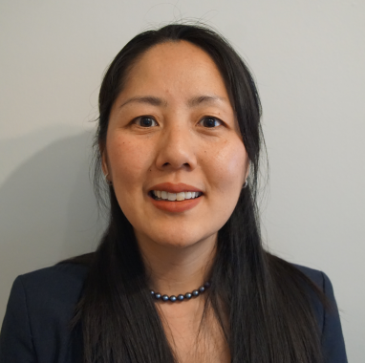
Dr. Tamy Kim, Director for Regulatory Affairs and Policy, OCE, FDA
Tamy Kim, PharmD is the Director for Regulatory Affairs and Policy, Oncology Center for Excellence (OCE) and Supervisory Associate Director for Regulatory Affairs Office of Oncologic Diseases (OOD), CDER. Dr. Tamy Kim is the Director for Regulatory Affairs and Policy in the Oncology Center for Excellence and Supervisory Associate Director for Regulatory Affairs Office of Oncologic Diseases at the FDA. In OOD, her responsibilities include developing policies related to review processes, including for breakthrough therapies, expedited reviews and safety. In the OCE, Dr. Kim is responsible for developing policies and procedures affecting the review of oncology products under the OCE across CDER, CBER and CDRH, including innovative review programs that are developed to expedite review of oncology drugs in a thorough manner.

Dr. Margaret Hattori-Uchima, Professor, University of Guam
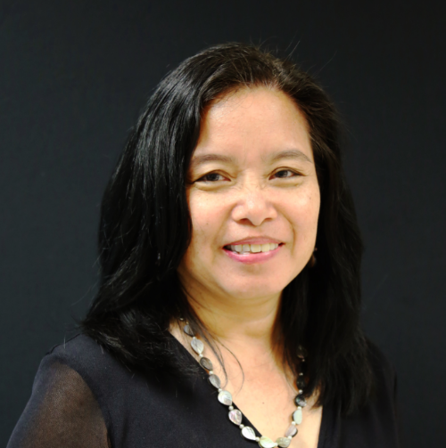
Margaret Hattori-Uchima, PhD, RN, FAAN, is the Dean of the University of Guam School of Health. She was the 2019 Guam Nurse of the Year awarded by the Guam Nurses Association. In 2020, she was inducted into the American Academy of Nursing as the first Nursing Fellow from Guam. Dr. Hattori-Uchima has provided leadership in the study and alleviation of health disparities and had a significant impact in the arenas of education, practice, and health care. She secured significant funding for the HRSA funded Guam/Micronesia Geriatrics Workforce Enhancement Program which aims to fill gaps in care for the elderly and those with Alzheimer’s Disease and related dementias through workforce development, family/caregiver training, and enhancement of practice environments. Dr. Hattori-Uchima is the contact PI for the NIMHD U24 : A cohort for Studying the Burden of Cardiometabolic Diseases in Guam and Pohnpei. She is one of the Guam co-MPIs in the NCI U54 Pacific Islands Partnership for Cancer Health Equity, and Guam lead investigator in the NIH BUILD EXITO (Building Infrastructure Leading to Diversity Enhancing Cross-Disciplinary Infrastructure and Training at Oregon). Her professional and academic collaborations target capacity building and research in health disparities, elder care, with emphasis on the needs of patients and families coping with Alzheimer's Disease, cancer disparities, and the biomedical training of underrepresented students in Micronesia. Dr. Hattori-Uchima has a BSN from the University of Hawaii, an MSN from University of Phoenix, and a PhD in Nursing from Villanova University.

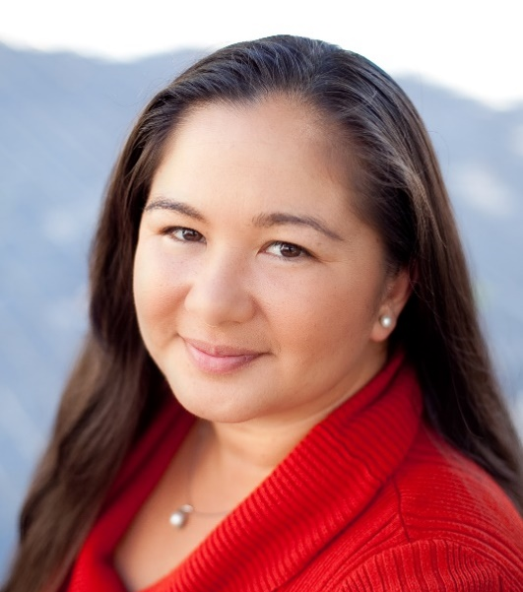
Dr. Christina K. Holub, Assistant Professor, California State University San Marcos
Dr. Christina Holub’s research focuses on developing prevention interventions to reduce health disparities through academic-community partnerships. As a recipient of the NIH LRP Program in the area of Health Disparities Research, Dr. Holub has a strong background in behavioral sciences, with publications in the area of cultural adaptation of self-report instruments and obesity prevention. During her postdoctoral years at San Diego State University, Dr. Holub led the evaluation of a physical activity randomized controlled trial among church-going Latinas (NCI). She also managed a CDC-funded Special Interest Project in collaboration with Mexico’s National Institute of Public Health aimed at developing culturally appropriate, evidence-based recommendations for obesity prevention interventions. More recently, Dr. Holub leads a pilot exercise program for Pacific Islanders in San Diego, CA, which was informed by the Pacific Islander Community Health (PIC Health) study, funded by the American Cancer Society, Health Disparities Program, 2013-2015. Currently, she is PI of an NIH/NIGMS-funded SuRE grant to develop innovative strategies to reduce health disparities among Pacific Islander and Latino communities (2022-2026). Dr. Holub is Department Chair and Assistant Professor in Public Health at California State University San Marcos. She is also affiliated with SDSU’s Institute for Behavioral and Community Health (IBACH). Dr. Holub received her MPH in Chronic Disease Epidemiology, with a focus on Social and Behavioral Sciences, from Yale University and PhD in Health Behavior from the University of North Carolina at Chapel Hill.
Dr. Yuling Hong, Branch Chief, NHLBI/NIH
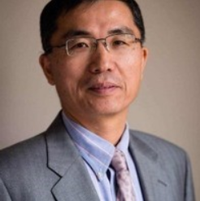
Dr. Hong is currently Chief of the Epidemiology Branch, Division of Cardiovascular Sciences, NHLBI, NIH. The Epidemiology Branch provides leadership and oversight for a dozen of large population-based longitudinal cohort studies. Prior to joining the NHLBI in July 2020, he was Associate Director of Science in the Division for Heart Disease and Stroke Prevention, CDC for more than 10 years and directed the American Heart Association Statistics and Epidemiology Unit for 8 years. His areas of expertise include cardiovascular epidemiology and prevention, genetic epidemiology, and evidence-based guideline development.

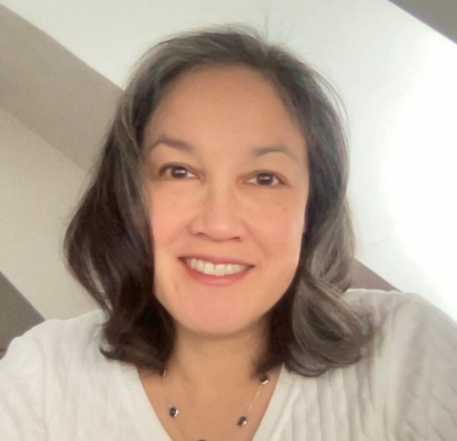
Dr. Naomi Horiba, Medical Officer, FDA
Naomi Horiba, MD, MPH, is a graduate of Tulane University Medical School where she also completed her Master’s in Public Health degree and residency training in internal medicine. She performed her medical oncology and hematology training at the University of Maryland Marlene and Stewart Greenebaum Comprehensive Cancer Center and practiced there as a faculty member for 6 years, subspecializing in gastrointestinal malignancies. During that time, she maintained a large practice and participated in and co-authored numerous multicenter clinical trials. In 2015, Dr. Horiba joined the U.S. Food and Drug Administration’s Office of Oncology Drugs as a medical reviewer and is currently serving on the gastrointestinal malignancies team. She has an interest in healthcare disparities and has co-chaired a recent session of the Oncology Center of Excellence’s Conversations on Cancer entitled “Advancing Equity in Asian American and Pacific Islander (AAPI) Communities: Racism and Injustice”.
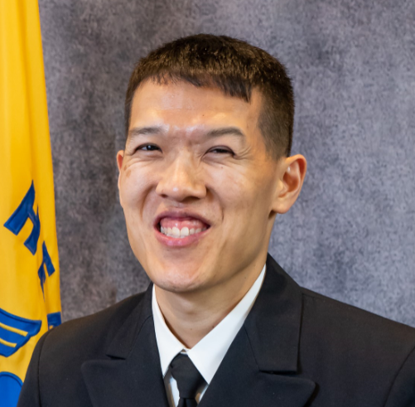
Dr. David Huang, National Center for Health Statistics, CDC
A nationally recognized expert in health indicators, data, and disparities, David T. Huang (CDR, US Public Health Service) is the Chief of the Health Promotion and Statistics Branch, which provides primary statistical and epidemiological support for the Department of Health and Human Services' Healthy People initiative at the CDC’s National Center for Health Statistics. In this role, he is the principal statistical advisor to the department on national health goals established through the initiative every ten years. CDR Huang is a member of the charter class of Certified in Public Health (CPH) professionals and has authored scientific work appearing in several prominent journals, in addition to serving as a contributing author for seminal federal publications on Healthy People 2010, 2020, and 2030. An officer in the US Public Health Service Commissioned Corps since 2011, CDR Huang has supported numerous federal public health emergency response efforts, including 170 days in the past 2 years for COVID- and disaster-related deployments. His educational background includes a PhD in Industrial Engineering (Health Systems) from the Georgia Institute of Technology and an MPH in quantitative methods from the Harvard T. H. Chan School of Public Health.


Dr. Nadia Islam, Associate Professor, New York University
Nadia Islam, PhD, is an Associate Professor in the Department of Population Health at the NYU Grossman School of Medicine and the Associate Director for NYU Langone’s Institute for Excellence in Health Equity. Her rigorous research program, marked by a collaborative approach involving multiple clinical and community stakeholders, focuses on developing culturally relevant community-clinical linkage models to promote health equity in disadvantaged communities. Dr. Islam co-directs the NYU-CUNY Prevention Research Center (PRC) and the Community Engagement and Population Health Research core of NYU’s Clinical Translational Science Institute. She is also a lead investigator in the NYU Center for the Study of Asian American Health, the nation’s only NIH-funded research center of excellence dedicated to eliminating disparities in Asian communities. Dr. Islam is the principal investigator on several NIH- and CDC-funded initiatives evaluating the impact of community health worker (CHW) interventions on chronic disease management and prevention in diverse populations. Dr. Islam is a medical sociologist with a doctorate in Sociomedical Sciences from Columbia University. Her work has been featured in the New England Journal of Medicine, JAMA, American Journal of Public Health, and numerous other peer-reviewed journals.
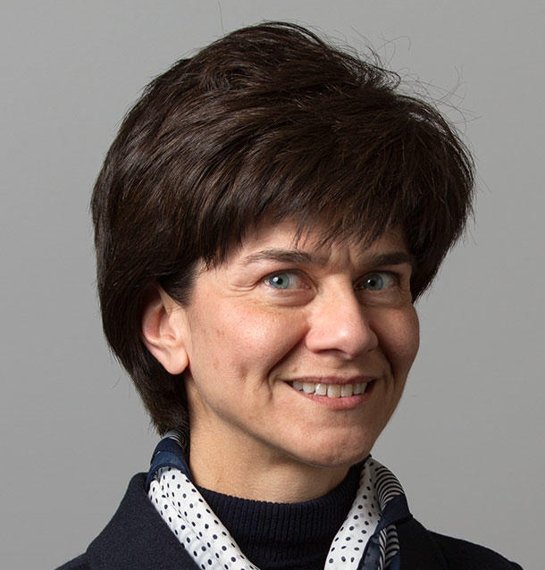
Dr. Maria Teresa Landi, Senior Investigator, DCEG, NCI
Dr. Landi received an M.D. summa cum laude from the University of Milan, Italy, and was trained in oncology and general medicine at the San Raffaele Hospital, University of Milan. She received a Ph.D. in occupational medicine and industrial hygiene, subgroup of molecular epidemiology, from an Italian University Consortium in 1993, and qualified for the associate professorship in occupational medicine and industrial hygiene in the Italian Universities in 1998. Dr. Landi received tenure in the Division of Cancer Epidemiology and Genetics (DCEG), NCI in 2006. She is an Associate Professor of Epidemiology at the Johns Hopkins Bloomberg School of Public Health, Baltimore, Maryland. Dr. Landi has assembled a team of investigators, including intramural and extramural scientists, to conduct complex germline and somatic genomic analyses in population studies. In 2021, she was appointed Senior Advisor for Genomic Epidemiology in DCEG's Trans-Divisional Research Program.

Dr. Alka Kanaya, Professor, University of California, San Francisco
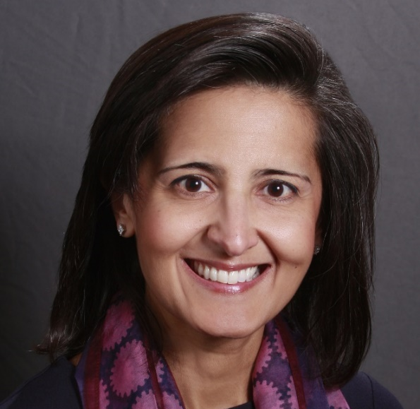
Dr. Alka Kanaya is Professor of Medicine, Epidemiology and Biostatistics at the University of California, San Francisco (UCSF) in the Division of General Internal Medicine. Dr. Kanaya has focused her research program on type 2 diabetes and cardiovascular disease epidemiology and prevention, specifically understanding Asian American health disparities over the past two decades. She is leading the Mediators of Atherosclerosis in South Asians Living in America (MASALA) Study to better understand factors that explain the high rates of diabetes and heart disease among South Asians. She is a practicing general internist and leads the CTSI research training programs at UCSF.

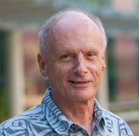
Dr. Loic Le Marchand, Professor, University of Hawai’i
Loïc Le Marchand, MD, PhD is a Professor in Epidemiology and the Associate Director for Community Outreach and Engagement and Cancer Disparities at the University of Hawai’i Cancer Center. He has published extensively on the role of lifestyle factors in the etiology of lung, colorectal and breast cancers, especially in regard to explaining racial/ethnic differences in risk. He is the founder of the Hawai’i Colorectal Cancer Family Registry, has led several large multi-projects grants and, since 2012, has been the Contact PI of the Multiethnic Cohort (MEC) Study. Dr. Le Marchand was among the first to show the existence of racial/ethnic differences in the risk of lung cancer associated with smoking. With collaborators at the University of Minnesota, he showed that the lower lung cancer risk of Japanese for a given lifetime smoking history is likely due to their slower nicotine metabolism, leading them to draw less nicotine and, as the result, less carcinogens, from each cigarette. They went on to show that the same CYP2A6 variants associated with nicotine metabolism were also associated with lung cancer. Among 1,861 MEC participants who underwent a whole-body DXA and abdominal MRI, Dr. Le Marchand and colleagues showed that visceral fat (VAT), adjusted for total adiposity, was highest among Japanese Americans, lowest among African Americans, and intermediate among Hawaiians, Latinos, and whites. Using biomarkers, they developed a VAT prediction score that was associated with risks of breast cancer independently of BMI and other risk factors in MEC.

Dr. Rachael T. Leon Guerrero, Professor, University of Guam
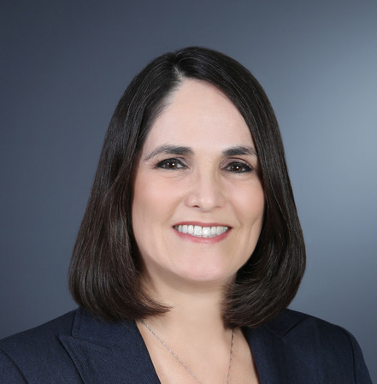
Dr. Rachael Leon Guerrero is the Vice Provost of Research and Sponsored Programs (ORSP) at the University of Guam, where she provides administrative oversight to the directors of Water and Environmental Research Institute of the Western Pacific (WERI), UOG Marine Lab, Center for Island Sustainability (CIS), Sea Grant, UOG Center for Excellence in Developmental Disabilities Education, Research and Service (CEDEERS), NSF EPSCoR, NASA EPSCoR, and the UOG Cancer Research Center. Dr. Leon Guerrero earned a Ph.D. in Human Nutrition from Colorado State University, an M.S. in Human Nutrition from the University of Hawaii, and a B.A. in Biology from the University of Guam. She is also a registered dietitian/nutritionist (RDN) with the Academy of Nutrition and Dietetics. Although her primary responsibility at the University is her administrative role in ORSP, she is also involved in several ongoing research projects, including:
- Contact PI, University of Guam/Cancer Research Center of Hawaii Partnership (NIH/NCI 2U54-CA-143728)
- Guam PI, Puipuia le Ola: Increasing reach and uptake of COVID-19 testing among Pacific Islanders in Hawaii and Guam (NIH 3P30GM114737-05S1)
- Guam PI, Children’s Healthy Living Center of Excellence — CHL Center. (USDA-NIFA 2013-68001-30335).
- Co-PI, EPSCoR RII Track-1: Guam Ecosystems Collaboratorium for Corals and Oceans (NSF OIA-1946352)
- Co-PI, A Cohort for Studying the Burden of Cardiometabolic Diseases in Guam and Pohnpei — PICCAH Study (NIH/NIMHD 1U24MD011201-01)
- Director, UOG Cooperative Ecosystem Study Unit (CESU) Program

Dr. Sandra Soo-Jin Lee, Professor, Columbia University
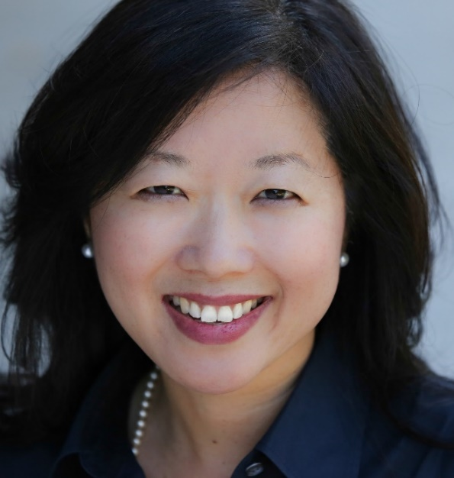
Sandra Soo-Jin Lee, PhD, is Professor of Medical Humanities and Ethics and Chief of the Division of Ethics at Columbia University. Trained as a medical anthropologist, Dr. Lee has extensive experience leading multi-disciplinary bioethics research on race, ancestry and equity in genomics, precision medicine and artificial intelligence, governance of biorepositories and commercialization of biotechnology. Dr. Lee publishes broadly in the genomics, medical, bioethics, and social science literatures, and co-edited Revisiting Race in a Genomic Age (2008). Her NIH/NHGRI funded studies include the Ethics of Inclusion: Diversity in Precision Medicine Research; Beyond Consent: Patient Preferences for Governance of Use of Clinical Samples and Data; and Social Networking and Personal Genomics: Implications for Health Research. Dr. Lee is Co-PI of the NIH funded Center for ELSI Resources and Analysis (CERA) and Co-Director of the Biennial International ELSI Congress. Dr. Lee currently serves as President-elect of the Association of Bioethics Program Directors, and on the US Health and Human Services Secretary’s Advisory Committee on Human Research Protections, the Scientific Advisory Board of the Human Pangenome Research Consortium and on the editorial boards of the American Journal of Bioethics and Narrative Inquiry in Bioethics. Dr. Lee is a member of the National Academies of Science, Engineering and Medicine’s Committee on the Use of Race, Ethnicity, and Ancestry as Population Descriptors in Genomics Research and is a Hastings Center Fellow. Dr. Lee received her doctorate from the UC Berkeley/UCSF joint program in Medical Anthropology and her undergraduate degree in Human Biology from Stanford University.
Dr. Jinyu Liu, Associate Professor, Columbia University
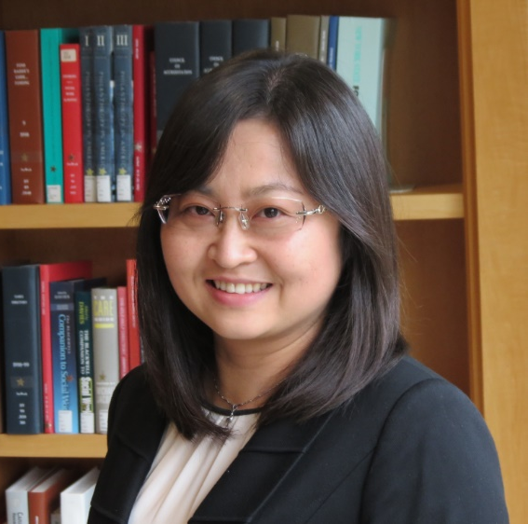
Dr. Jinyu Liu’s is an associate professor in Columbia University School of Social Work. Dr. Liu studies determinants of stress among Chinese family caregivers and effects of social support on the mental health of Asian older adults. Her scientific contributions in the field of stress among Chinese caregivers have: (1) identified unique stressors; (2) quantified the effects of multiple traits of ethnic culture on caregiver’s mental health; and (3) suggested diverse, life-course relevant and culturally oriented needs and strengths. Her research in this theme has made contributions to the field of supportive environment and mental health of Chinese older adults by (1) elucidating the nuanced effects of family relationships on the mental health of older adults during social and cultural transformations; and (2) exploring social connections and community resources to enhance the mental health of older adults who were socialized in a family-oriented cultural tradition. This knowledge is essential for the development of culturally sensitive services and policies to improve the mental health of Chinese older adults and their family caregivers in China and in the United States. Her current research projects include developing and testing culturally-sensitive interventions to reduce stress of dementia caregivers in Chinese American communities and examining technology use and mental health among Asian older immigrants in the United States. Dr. Liu’s work has been funded by National Institute of Aging, the Columbia Population Research Center, the Rutgers RCMAR center, and the Columbia School of Social Work.

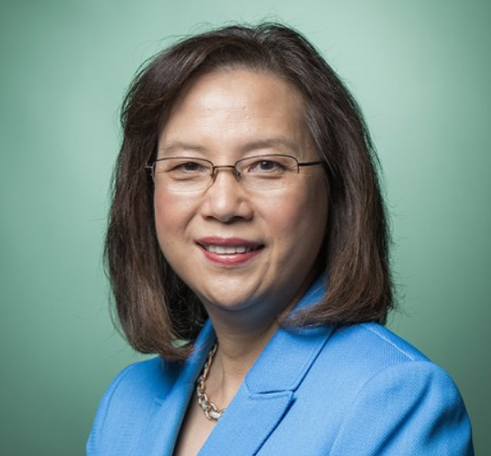
Dr. Grace X. Ma, Associate Dean & Professor, Temple University
Grace X. Ma, PhD is Associate Dean for Health Disparities, Founding Director of Center for Asian Health, Laura H. Carnell Professor at Lewis Katz School of Medicine and Fox Chase Cancer Center at Temple University. Dr. Ma is a nationally recognized population health scientist and pioneer in cancer and health disparities research. In 2000, she established Center for Asian Health (CAH), among nation’s first centers dedicated to reducing cancer health disparities in underserved Asian Pacific Americans (APA). Over the past 20 years, Dr. Ma as Principal Investigator has directed 4 cycles of NCI/NIH funded cancer health disparities research centers/networks across PA, NJ and NYC region. Dr. Ma conducted numerous cluster randomized trials that demonstrated evidence-based culturally appropriate interventions to address multilevel determinants of health and improve health outcomes in cancer screening/early detection (e.g., Hepatitis-related liver disease, lung, colorectal, breast, and cervical cancers), healthcare access, and quality of care in diverse APA populations. Dr. Ma currently Co-Chairs AA NHPI Interest Group for NIH Community Engagement Alliance (CEAL) Against COVID-19 Disparities.
Dr. Alika Maunakea, Associate Professor, University of Hawai’i
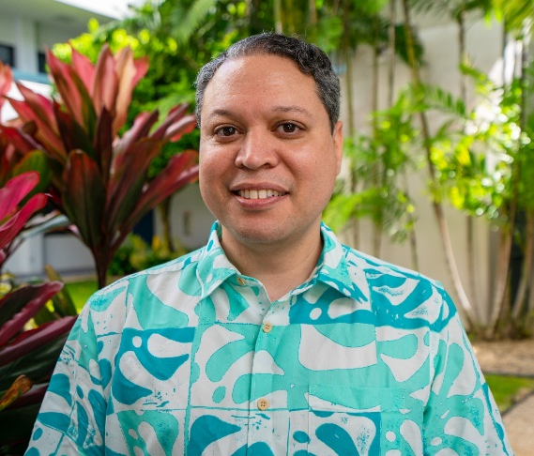
Native Hawaiian born and raised in Waiʻanae, Hawaiʻi, Dr. Maunakea received his B.Sc. degree in Biology at Creighton University (2001) and Ph.D. in Biomedical Sciences at the University of California, San Francisco (2008). He completed Postdoctoral training at the National Institutes of Health (2012) and has since joined the John A. Burns School of Medicine at the University of Hawaiʻi, Mānoa. In studying epigenetics for over 20 years, Dr. Maunakea has made several important contributions that have helped advance the field. In particular, he has developed and applied novel high-throughput, genome-wide technologies that survey DNA methylation and histone modifications, both central components of epigenetic processes, and has discovered novel roles for DNA methylation in regulating alternative promoter usage and in pre-mRNA splicing. Currently, as Associate Professor in the Department of Anatomy, Biochemistry, and Physiology, Dr. Maunakea applies epigenomic information toward understanding the mechanistic relationships of gene-environment interactions that underlie the development of diseases of health disparities as well as promotes diversity in the research workforce. He leads and collaborates with a cadre of clinical, behavioral, economic, and health disparities researchers on various community-based biomedical research projects while simultaneously mentors underrepresented minority students in multidisciplinary research careers. Because cardiometabolic diseases, including diabetes, are major health disparities in the Native Hawaiian and Pacific Islander (NHPI) population, Dr. Maunakea seeks to better understand the socioecological determinants that influence epigenomic and cellular events that regulate inflammatory states that appear to underlie progression of these diseases to enable prevention, the goal of his R01-funded study.

Dr. Elizabeth Rose Mayeda, Assistant Professor, University of California, Los Angeles
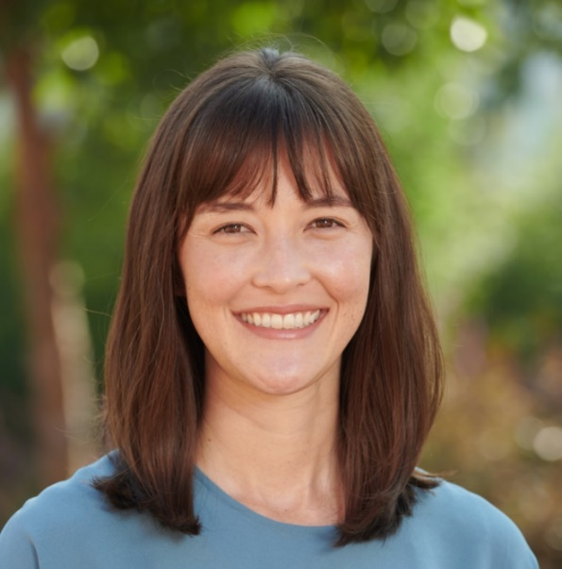
Elizabeth Rose Mayeda is an Assistant Professor in the Department of Epidemiology at the UCLA Fielding School of Public Health. The substantive focus of Dr. Mayeda's research is on identifying the origins and lifecourse mechanisms of racial and ethnic disparities in Alzheimer’s disease and related dementias. To address these research questions rigorously, Dr. Mayeda's work emphasizes methods to strengthen causal inference, especially tools to quantify and remediate selection bias arising from selective sampling, attrition, or survival. She is recognized as an emerging leader in the fields of epidemiology and dementia research: in 2019, she served as a member of the Health Disparities Session of the NIH Alzheimer’s Disease-Related Dementias Summit and gave an NIH Rising Star Invited Lecture, and in 2020, she received the Society for Epidemiologic Research Brian MacMahon Early Career Award.
Dr. Chong-xian Pan, Associate Professor, Harvard Medical School
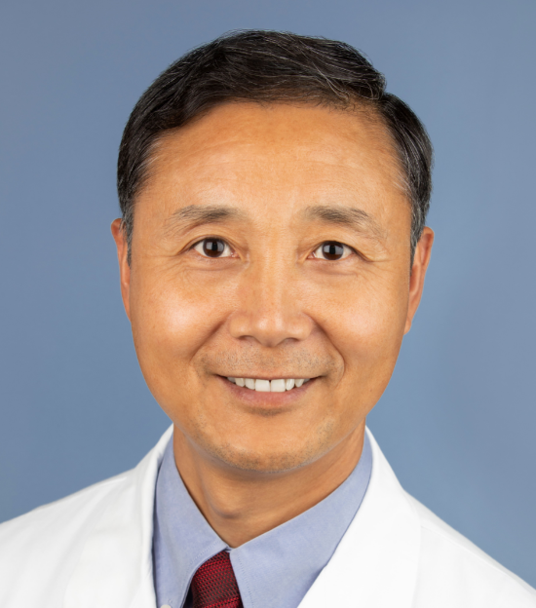
Chong-xian Pan, MD, PhD, MS: Dr. Pan is a Board-certified practicing medical oncologist, physician-scientist and immunologist. Currently, he is an Associate Professor of Medicine at Brigham and Women’s Hospital, Harvard Medical School, and Staff Physician of the VA Boston Healthcare System. As a physician-scientist in Hematology/Oncology, he has broad background and training in both basic research and clinical science, understands what clinicians need and how the basic and preclinical studies can be translated into clinical applications. His lab focuses on translational research that can be directly converted to clinical trials. He has translated preclinical studies from his own group into six clinical trials and served as the PI of these trials. He organized three cGMP (current Good Manufacturing Practices) preparations for four of these trials, designed the clinical trial protocols, obtained the regulatory approvals including IND (Investigational New Drug) filing, and conducted the trials. In addition, he has been leading the development of three novel cancer-specific targeting nanoparticles from the very beginning target identification and development to the pre-IND/IND stage. Furthermore, he organized and served as the contact PI of a multi-center U54 grant to establish patient-derived xenografts (PDXs), and conduct translational and health disparity research among University of California (UC) Davis, UC San Francisco, UC Los Angeles and UC Irvine. This U54 program is one of the only two minority PDX centers funded by NCI and is the only center on lung and bladder cancers on which he leads the cancer health disparity research.

Dr. Latha Palaniappan, Professor, Stanford University
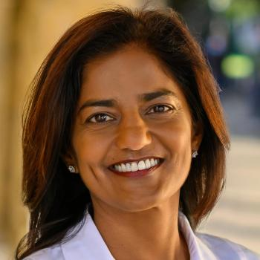
Latha Palaniappan MD, MS, is an internist and clinical researcher. Her research has focused on the study of diverse populations, chronic disease and prevention. Dr. Palaniappan specifically seeks to address the gap in knowledge of health in Asian subgroups and other understudied racial/ethnic minorities (PACS 5R01DK081371, CASPER R01HL126172, and CAUSES R01MD007012). During her time at Palo Alto Medical Foundation (PAMF) as the Medical Director of Clinical Research, she led the organization-wide initiative to collect patient race/ethnicity and language information, enabling PAMF researchers to conduct disparities research using electronic health records. She was the co-founder of PRANA (along with Dr. Ronesh Sinha), a South Asian Wellness program. Her current work examines the clinical effectiveness of structured physical activity programs for diabetes management (Initiate and Maintain Physical Activity in Clinics - IMPACT, 5R18DK096394), as well as best exercise regimens for normal-weight diabetics (Strength Training Regimen for Normal Weight Diabetics - STRONG-D, 2R01DK081371). She was recently awarded a Midcareer Investigator Award (K24 HL150476) by the National Institutes of Health to provide mentoring to junior clinical investigators in the conduct of patient oriented research. She is currently working on implementation of evidence based genetic and pharmacogenetic testing in Primary Care Clinics as the Scientific Director of Precision Genomics and Pharmacogenomics in Primary Care (with Dr. Megan Mahoney). She is the Faculty co-Director of the Stanford Biobank (with Drs. Brooke Howitt and Joachim Hallmayer) designed to accelerate translatable scientific discoveries. She co-founded (with Dr. Bryant Lin) the Center for Asian Health Research and Education (CARE) at Stanford in 2018.
Fornessa Randal, co-director, University of Chicago Center for Asian Health Equity
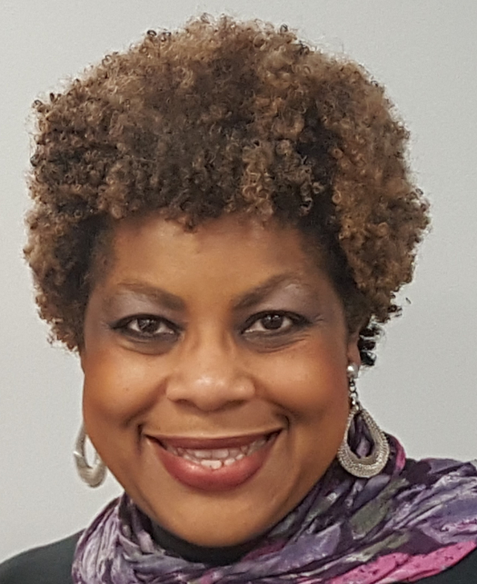
Ms. Fornessa T. Randal is the Co-Director of the University of Chicago’s Center for Asian Health Equity (CAHE) and Executive Director for the Asian Health Coalition, a non-profit community-based organization. Ms. Randal has over 20 years of experience in health systems innovation, as well as minority and community health planning and implementation. Her background extends to cancer disparities research, public health, outreach and community-based participatory research (CBPR). Fornessa has disseminated and transformed local health initiatives into statewide and national models and developed prototypes, which have been recognized by both the National Institutes of Health (NIH) and Centers for Disease Control and Prevention. She is the Principal Investigator for several federally funded programs, including the NIH’s All of Us Research Program and is Chair for the Asian Engagement and Recruitment Core. Fornessa has authored and co-authored several peer-reviewed articles and is a leader in health equity.

Dr. Nicolas Robine, Director, Computational Biology, New York Genome Center
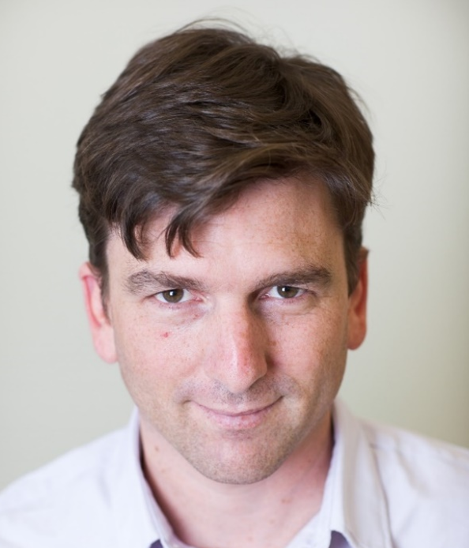
Nicolas Robine joined the New York Genome Center in April 2012. He graduated from an Engineering school in Paris (ESIEE-Paris), with an Msc in Bioinformatics from Goteborg (Sweden) and obtained his PhD at the Institut Curie in Paris for his work on the analyses of meiotic double-strand breaks in yeast. He did a postdoc at the Sloan-Kettering Institute in New York in the lab of Eric Lai, working on the annotations of drosophila small RNA (microRNA and piRNA) within the modENCODE consortium. At the New York Genome Center, where his current position is Director, Computational Biology, he supervise a group of bioinformatics scientists and analysts, with projects applied to cancer genomics (tumor-normal whole-genome analysis, liquid biopsy, tumor evolution) and functional genomics (RNASeq, single-cell RNA, multi-modal).

Dr. Ana I. Robles, Program Director, OCCPR, NCI

Dr. Ana I. Robles is a Program Director in the Office of Cancer Clinical Proteomics Research (OCCPR) at the National Cancer Institute (NCI). A cancer biologist, she provides scientific management, leadership and oversight to large-scale proteogenomics programs, including the Clinical Proteomic Tumor Analysis Consortium (CPTAC), and the International Cancer Proteogenome Consortium (ICPC). Prior to joining OCCPR, Dr. Robles was an Associate Scientist at the NCI, focused on molecular epidemiology and the identification and functional characterization of lung cancer biomarkers. Her studies aimed to integrate genomic, epigenetic, transcriptomic and microbiome data generated in well-characterized patient populations to improve patient stratification into risk categories and illuminate lung cancer biology. Dr. Robles has co-authored 3 book chapters and over 100 publications in peer-reviewed journals and is member of journal Editorial Boards. Throughout her career at the NCI, Dr. Robles has mentored over 40 students, trainees, and postdoctoral fellows. She received the NCI Director's Award for Oversight of Programmatic Vision as part of the CPTAC Program Team, the NCI Director’s Innovation Award for her work leveraging DNA methylation for diagnosis and prognosis of lung cancer, and numerous mentoring and travel awards. Dr. Robles completed undergraduate training in Chemistry at University of Buenos Aires, Argentina, holds a Ph.D. degree in Cancer Biology from the Graduate School of Biomedical Sciences at the University of Texas, where she was a Rosalie B. Hite Pre-Doctoral Fellow, and completed postdoctoral training in the NCI Laboratory of Human Carcinogenesis.

Dr. Raynald Samoa, Assistant Professor, City of Hope
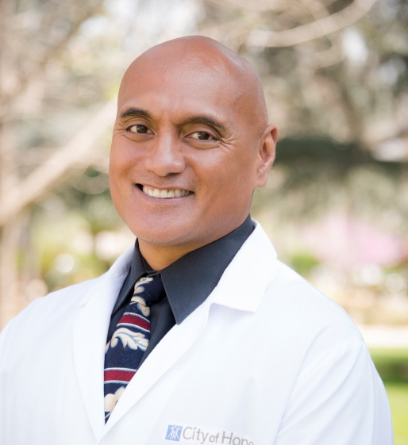
Dr. Raynald Samoa is an endocrinologist at the City of Hope. His research focuses on improving diabetes outcomes in high-risk populations such as Pacific Islanders and cancer survivors. Dr. Samoa served as the Lead for the National Pacific Islander COVID-19 Response Team and has authored several manuscripts describing the impact of COVID-19 on Pacific Islander communities. He has testified to the House of Representative Ways and Means Committee during a session entitled THE DISPROPORTIONATE IMPACT OF COVID-19 ON COMMUNITIES OF COLOR. Dr. Samoa serves on the President’s Advisory Commission on Asian Americans, Native Hawaiians, and Pacific Islanders and is the Co-Chair of the Data Disaggregation subcommittee. He currently is the technical advisory lead for the Healing Association of Pacific Islander Physicians (HAPI Physicians) and the Data and Research Council Chair of the National Association of Pacific Islander Organizations (NAOPO).
Dr. Shankha Satpathy, Scientist, Broad Institute
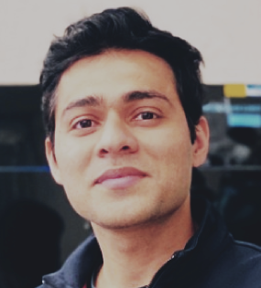
Shankha Satpathy is a senior group leader in the Proteomics Platform at the Broad Institute of MIT and Harvard. As part of the proteomics group at Broad, he is involved in several proteomics technology development areas, and also contributes to academic- and industry-partnered collaborative projects using mass spectrometry and other proteomic tools to investigate interesting biological questions with potential translational impact. His work intersects multiple disciplines and involves both basic scientists and clinicians. He is a key member of the CPTAC consortium and leads several clinical proteomics and proteogenomic projects. Of note was the development of a proteogenomics workflow for core-needle biopsy and its application in a range of solid tumor clinical trials, and the comprehensive proteogenomic characterization of breast cancer, lung adenocarcinoma, and lung squamous cell carcinoma that Satpathy co-led with research groups within the CPTAC consortium. Satpathy joined the Broad in September 2017 as a postdoctoral associate in the laboratory of Steven Carr. He has been a staff scientist since 2019, and is a senior group leader in proteomics since 2022. He conducted his doctoral research in the application of proteomics to decipher immune signaling pathways, at the Novo Nordisk Foundation Center for Protein Research in Copenhagen and earned his Ph.D. from the University of Copenhagen in 2017. He also holds a M.S. in biochemistry and molecular biology from the Cumming School of Medicine, University of Calgary and a B.Tech. in biotechnology from Vellore Institute of Technology, India. As part of the Broad, he loves working in a fast paced and collaborative environment surrounded by motivated and inspiring colleagues.

Dr. Arthur Sherman, Senior Investigator, NIDDK, NIH
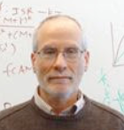
Dr. Sherman was trained as an applied mathematician with interests in scientific computing and mathematical biology at New York University under Charles Peskin. After receiving his Ph. D. in 1986, he joined the Mathematical Research Branch (MRB), NIDDK, as a post-doctoral fellow with John Rinzel. His work initially centered on modeling the calcium and electrical activity that underlie pulsatile insulin secretion from pancreatic beta cells, with parallel work on electrical activity in neurons and pituitary cells and on neurotransmitter release. He was promoted to tenure track in 1989 and was tenured in 1996. In 2005 he became chief of the MRB, which was renamed the Laboratory of Biological Modeling (LBM). Today LBM hosts four principal investigators whose work covers a range of focus areas related to diabetes, including obesity and metabolism, as well as other efforts that can be broadly characterized as systems biology. Recently Dr. Sherman's work on the normal functioning of beta cells has turned toward modeling the role of beta-cell failure combined with insulin resistance in the pathogenesis of type 2 diabetes. An important aspect of this work is clarifying the different pathways to diabetes, chiefly insulin-resistant vs insulin-deficient. This aligns closely with the predominant patterns in Europeans and East Asians, respectively.
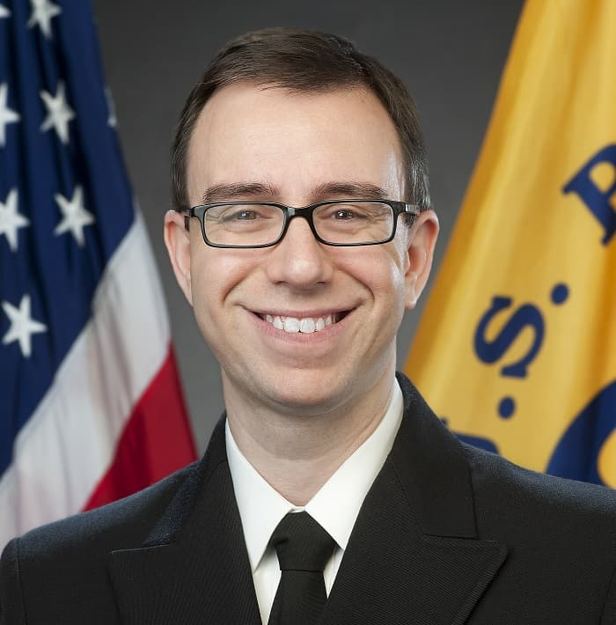
Dr. David Siegel, Medical Officer, Division of Cancer Prevention and Control, CDC
David Siegel, MD, MPH, is a pediatric hematologist/oncologist and a Lieutenant Commander in the Commissioned Corps of the U.S. Public Health Service. He joined the Centers for Disease Control and Prevention as an Epidemic Intelligence Service Officer in the Division of Cancer Prevention and Control (DCPC) from 2016 to 2018 and remained in DCPC as a medical officer. Dr. Siegel focuses his work and research on pediatric, young adult, prostate, and tobacco-associated cancers and on using cancer registry data to improve disparities in clinical trial enrollment and outcomes. Dr. Siegel attended Washington University in St. Louis for his undergraduate studies and the George Washington University School of Medicine for medical school. He completed a pediatric residency and a pediatric hematology/oncology fellowship at Emory University and Children’s Healthcare of Atlanta.

Dr. Mingyang Song, Assistant Professor, Harvard T.H. Chan School of Public Health
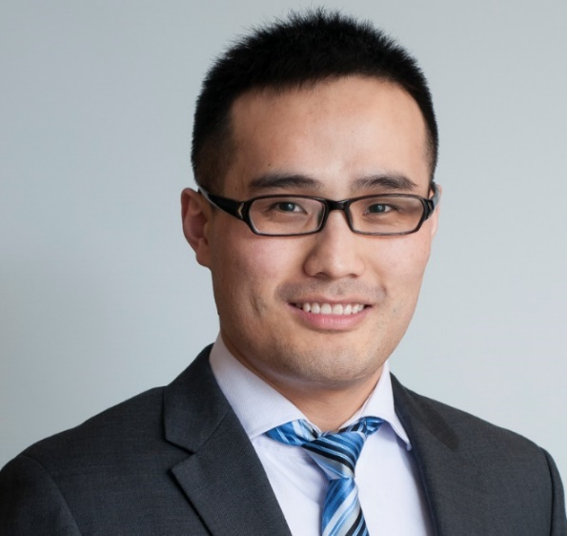
Mingyang Song, MBBS, ScD is an Assistant Professor of Clinical Epidemiology and Nutrition at Harvard T.H. Chan School of Public Health and an Assistant Professor of Medicine at Massachusetts General Hospital, Harvard Medical School. Dr. Song received his joint doctoral degree in Nutrition and Epidemiology in 2015 from Harvard T.H. Chan School of Public Health. Dr. Song’s research focuses on nutritional and translational epidemiology of cancer. His work has two main themes. The first is to integrate large-scale observational studies with biomarker-based randomized clinical trials to identify novel nutritional and gut microbiota-targeted strategies for cancer prevention and treatment. The second theme involves integration of electronic health record (EHR) data with molecular profiling for developing cost-effective risk assessment tools for precision cancer screening and surveillance. Dr. Song was awarded the NextGen Star by the American Association for Cancer Research. His current research is supported by the National Cancer Institute (K99/R00) and American Cancer Society. The ultimate goal of his research is to translate epidemiologic advances into the clinic for improved cancer prevention and treatment.
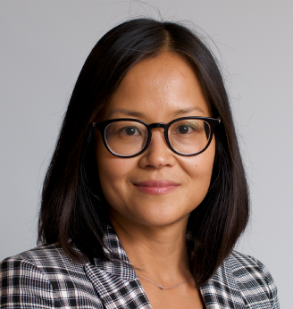
Dr. Nhi-Ha T Trinh, Assistant Professor, Harvard Medical School
Dr. Nhi-Ha Trinh, MD, MPH, serves as the Director for the Department of Psychiatry Center for Diversity at Massachusetts General Hospital. Dr. Trinh is committed to fostering a more diverse and inclusive academic community and is devoted to educating students, trainees, staff, and faculty in cultural humility and antiracism to improve patient care, the hospital workplace culture, and the medical learning environment. Dr. Trinh completed residency training in Adult Psychiatry at the Mass General/McLean Adult Psychiatry Training Program and a clinical fellowship in Geriatric Psychiatry at McLean Hospital, and has served as faculty at MGH since 2007.

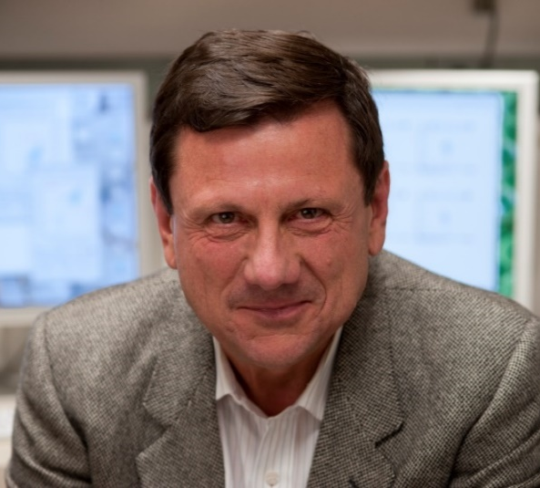
Dr. Giorgio Trinchieri, Senior Investigator, CCR, NCI
Giorgio Trinchieri (M.D. 1973, University of Torino, Italy) is NIH Distinguished Investigator and Chief of the Laboratory of Integrative Cancer Immunology, CCR, NCI. He worked at the Basel Institute for Immunology, the Medical Genetics Institute at the Medical School of Torino, the Wistar Institute and Department of Medicine of the University of Pennsylvania, the Swiss Institute for Experimental Cancer Research and the Schering Plough Laboratory for Immunological Research (Dardilly, France). Trinchieri work has focuse in innate immunity, cancer inflammation and human immunology. Trinchieri originally described the specificity of allogeneic cytotoxic T cells for class-I MHC and cross-presentation and class-I MHC restriction of tumor antigens. He contributed to the original characterization of human NK cells, described their role as innate producers of cytokines, identified type I IFNs as major activators of NK cells and discovered a new human cell type, now called plasmacytoid DC, as a major source of type I IFN in response to viruses. Trinchieri then identified the mouse counterpart of human plasmacytoid DC, paving the way for study their function in experimental mouse models of infections and tumors. Trinchieri discovered IL-12, a cytokine activating NK cells. and demonstrated its impact in innate immunity, Th-1 cell polarization, host responses to pathogens, cancer, and hematopoiesis. Recently, Trinchieri focused on the impact of cytokines and inflammation in cancer. In this field, he has demonstrated the importance of intestinal microbiota in influencing the immune responses to cancer and anti-cancer therapy in mouse models as well as in observational and interventional clinical studies.
Dr. Elizabeth Tung, Assistant Professor, University of Chicago Medicine
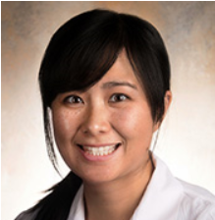
Dr. Tung is an assistant professor of medicine at the University of Chicago. Dr. Tung’s research focuses on disparities in chronic disease management, with a special interest in race, place, and poverty. She has participated in community-based strategies to improve chronic disease management in East St. Louis, Chinatown New York, and West Providence, in addition to her work on the South Side of Chicago. These experiences have led to a vested interest in addressing the social determinants of health and a commitment to eradicating health disparities. Her current research focuses on two main areas of inquiry. First, Dr. Tung is examining the relationships between race, poverty, and access to healthcare in adults with chronic disease, and has published on topics such as bypassing healthy resources, implicit bias, and retail redlining. Second, Dr. Tung is examining the intersection between community violence and chronic disease and is applying geospatial analytical tools to bridge the worlds of violence epidemiology and health.

Dr. Judy Huei-yu Wang, Associate Professor, Georgetown University
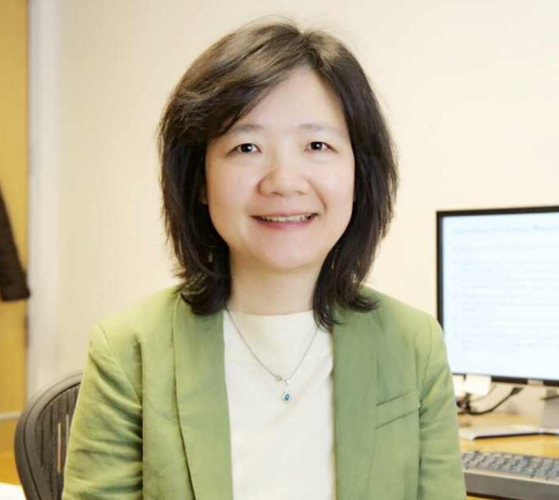
Judy Wang, Ph.D., is a tenured Associate Professor in the Department of Oncology and a member of the Lombardi Comprehensive Cancer Center at Georgetown University. Dr. Wang’s research area focuses on culture, psychology, and behavioral medicine. She has investigated multiethnic cancer patients’ symptom burden and conducted behavioral intervention trials to promote cancer patients’ quality of life. Her research also extends to global assessments of dietary patterns and liver cancer stigma among people in Asia and the United States. She uses qualitative and quantitative methodologies to investigate racial similarities and differences in cancer survivorship care to inform culturally competent care. The National Institutes of Health (NIH) has funded her research for over 18 years with additional funding through DOD, KOMEN, and the American Cancer Society. She has been serving as an NIH grant reviewer for various training and research awards. She has served as a Chair of the Faculty Development Committee, a founding member of the Faculty Diversity and Inclusion subcommittee at Georgetown University Medical Center, and an appointed member of the President’s Gender Equity Task Force at Georgetown University from 2018-2021. Dr. Wang teaches courses on cancer education, cancer screening and survivorship, behavioral intervention research, and evidence-based medical research.
Dr. Karriem Watson, Chief of Engagement Officer, NIH All of Us Research Program
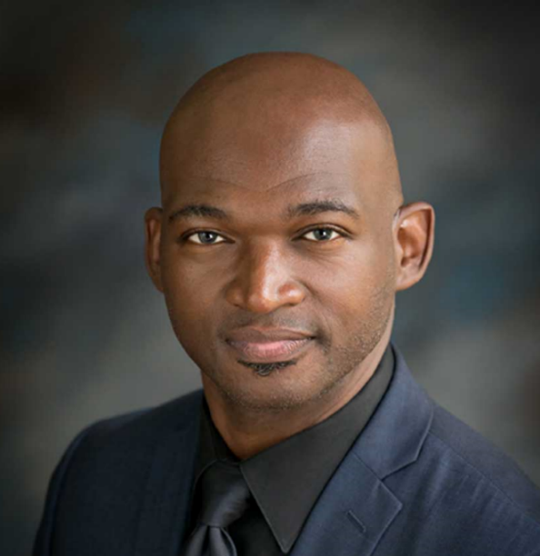
Dr. Karriem S. Watson, DHSc, MS, MPH is the Chief Engagement officer for the NIH All of Us Research Program. Dr. Watson comes to the NIH after 16 years in academia and community health. He previously served as the Associate Executive Director of a group of Federally Qualified Health Centers (FQHCs) in the Illinois area where he developed a community engaged and implementation science research program. He was also faculty at the University of Illinois School of Public Health Division of Community Health Sciences. Dr. Watson’s research focused on cancer prevention and control and he previously had a Multi-PI R01 from the NIMHD looking at epigenetics in lung cancer screening among African American men and was funded in a Multi-PI project through the NHLBI UG3/UH3 looking at the implementation of evidence based tobacco cessation in FQHCs. Dr. Watson also received funding from the NCI to develop a Citizen Science program that engaged African American men in prostate and lung cancer screening. In addition to his research, Dr. Watson has been recognized as a national leader in community engagement having served as the past chair of Community Campus Partnerships for Health (CCPH) and being recognized by the Lungevity as a Community Champion. He is also passionate about mentoring and training up the next generation of young scientists and was recognized by the Chicago Urban League as an Innovator in STEM.
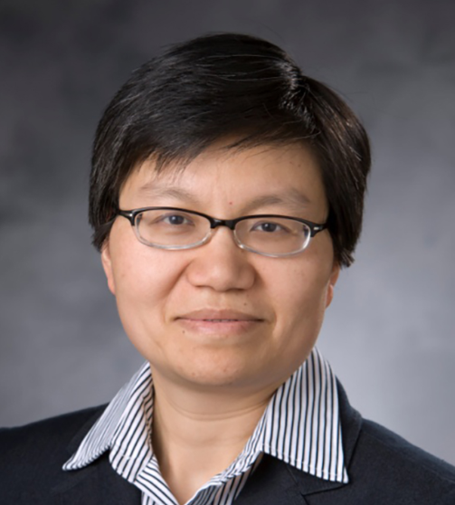
Dr. Bei Wu, Professor, New York University
Dr. Wu is Dean’s Professor in Global Health and Vice Dean for Research at the NYU Rory Meyers College of Nursing. She is an inaugural Co-Director of the NYU Aging Incubator. Dr. Wu is an internationally-known leader in gerontology. Her extensive publications cover a wide range of topics related to aging and global health, including oral health, long-term care, dementia, and caregiving. As a principal investigator, Dr. Wu has led a significant number of projects supported by the National Institutes of Health (NIH). She is currently leading several NIH funded projects including a clinical trial to improve oral health for persons with cognitive impairment/ She co-leads the NIH/NIMHD-funded Rutgers-NYU Center for Asian Health Promotion and Equity. Through this center, she leads a 5-year intervention study that focuses on supporting Chinese and Korean dementia caregivers who are at increased risk for high blood pressure and diabetes due to the physical and emotional demands of caregiving. She is a director of the Research and Education Core for the NIA-funded Asian Resource Center for Minority Aging Research (RCMAR). Dr. Wu has mentored dozens of minority aging researchers from various disciplines for the past two decades. Dr. Wu is a fellow of the Gerontological Society of America, Academy for Gerontology in Higher Education, and the New York Academy of Medicine.
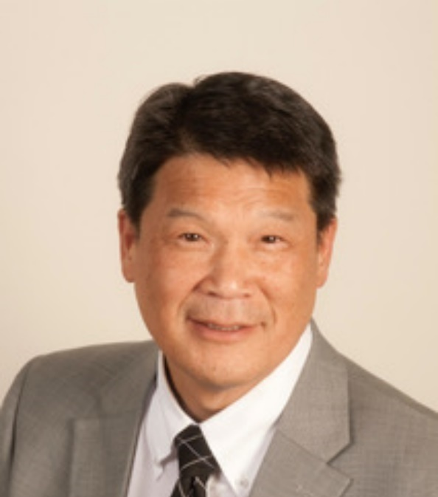
Dr. Winston Wong, Scholar in Residence at the UCLA
Winston Wong, MD, MS, FAAFP, is a Scholar in Residence at the UCLA Kaiser Permanente Center for Health Equity at the Fielding School of Public Health, UCLA. A fellow of the American Academy of Family Practice, Dr. Wong’s professional career has encompassed leadership roles at community health centers, federal service and most recently at Kaiser Permanente, where he served as Medical Director for Community Benefit for over 17 years. His commitment to addressing health equity is anchored by his experience as a bilingual primary care community health center physician for the Asian immigrant community in Oakland Chinatown, which led him to leadership roles in the United States Public Health Service, where he served as HRSA’s chief Clinical Officer for a region than spanned the Pacific and western United States. At Kaiser Permanente, he was responsible for its national philanthropic strategies to support clinical and population management initiatives with the safety net, and for its quality initiatives to address disparities within its 12 million membership. In 2016 he was appointed to the US DHHS Advisory Committee on Minority Health, and in 2019 was appointed chair. At the NASEM he chairs the Roundtable on Health Equity, and has served on the Board of Population Health and Public Health Practice. As a leader in philanthropy, he has active Board roles at the California Endowment and Grantmakers in Health. He also previously served as Board Chair for the School Based Health Alliance and is the current acting CEO and Chair of the National Council of Asian Pacific Islander Physicians. His work in developing programs and policies to address health equity has been recognized by awards from the California Primary Care Association, Latino Health Access, the Minority Health Foundation, Asian Health Services, and Congresswoman Barbara Lee. In addition to his 2020 Scholar in Residence appointment at UCLA, Dr. Wong received a Doctor of Humane Letters from the A.T. Still School of Osteopathic Medicine.
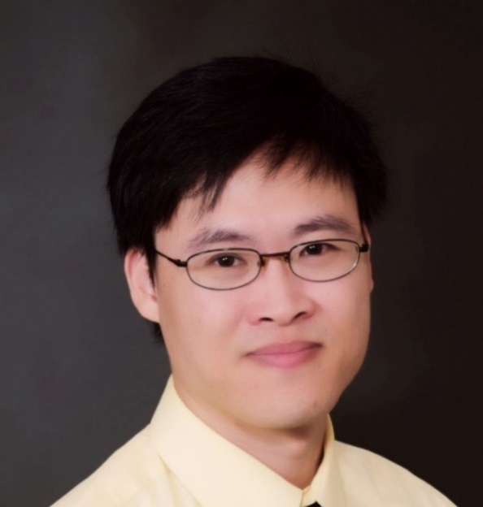
Dr. Changqing Xie, Physician-scientist Early Investigator, CCR, NCI
Dr. Xie received M.D. and Ph.D from the Xiangya School of Medicine of Central South University. He completed my postdoctoral training in the lab of Dr. Eugene Chen at Morehouse School of Medicine and at the University of Michigan before being promoted as junior faculty at the University of Michigan. Before he started Internal Medicine residency training at East Carolina University, he worked as an Assistant Research Professor at the University of Virginia. He completed Hematology/Oncology training through the NHLBI/NCI Hematology/Oncology Fellowship program mentored by Dr. Tim Greten and joined the Thoracic and Gastrointestinal (GI) Malignancies Branch as a Physician-Scientist Early Investigator in 2019. He is participating on clinical trials involved with liver cancer, colorectal cancer and pancreatic cancer, while exploring the role of cancer stem cells in the development of immunotherapy resistance in cholangiocarcinoma.
Dr. Stella Yi, Associate Professor, New York University
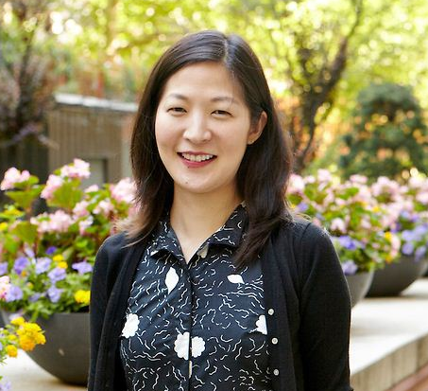
Stella Yi is an Associate Professor at the NYU Grossman School of Medicine, Department of Population Health, Section for Health Equity. Dr. Yi is an epidemiologist focused on health equity and social justice for Asian American and other immigrant communities. Her specific content area expertise is on community-partnered and culturally appropriate initiatives focused on nutrition and eating, cardio-metabolic disease and the collection of disaggregated race/ethnicity data at the local and state levels. Prior to joining faculty at NYU in 2014, she worked for six years at the NYC Department of Health and Mental Hygiene (DOHMH) leading research and evaluation efforts of city nutrition policies and community-clinic initiatives. Given these experiences, she possesses a unique viewpoint on health, policy and research that encompasses a citywide perspective paired with an understanding of unique health needs of disparity subgroups. Dr. Yi received her Masters in Public Health in Chronic Disease Epidemiology/Social Behavioral Sciences at the Yale School of Public Health and her doctorate in Epidemiology from the Johns Hopkins Bloomberg School of Public Health.

Dr. Shannon Zenk, Director, NINR, NIH
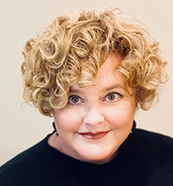
Shannon N. Zenk, PhD, MPH, RN, FAAN is the Director of the National Institute of Nursing Research. Dr. Zenk was previously a Nursing Collegiate Professor in the Department of Population Health Nursing Science at the University of Illinois Chicago (UIC) College of Nursing, and a fellow at the UIC Institute for Health Research and Policy. Dr. Zenk was elected as a fellow of the American Academy of Nursing in 2013, received the President’s Award from the Friends of the National Institute of Nursing Research in 2018, was inducted into the International Nurse Researchers Hall of Fame in 2019, and elected as a member of The National Academy of Medicine in 2021. She has spent time as a visiting scholar in Rwanda and Australia. She earned her bachelor’s in nursing, magna cum laude, from Illinois Wesleyan University, Bloomington; her master’s degrees in public health nursing and community health sciences from UIC; and her doctorate in health behavior and health education from the University of Michigan, Ann Arbor. Her predoctoral training was in psychosocial factors in mental health and illness, funded by the National Institute of Mental Health. Her dissertation examined racial and socioeconomic inequities in food access in metropolitan Detroit. She completed postdoctoral training in UIC’s Institute for Health Research and Policy’s Cancer Education and Career Development Program, funded by the National Cancer Institute, in 2006. Dr. Zenk’s own research focuses on social inequities and health with a goal of identifying effective, multilevel approaches to improve health and eliminate racial/ethnic and socioeconomic health disparities. Her research portfolio has included NIH-supported work into urban food environments, community health solutions and veterans’ health. Through pioneering research on the built environment and food deserts, Dr. Zenk and her colleagues increased national attention to the problem of inadequate access to healthful foods in low-income and Black neighborhoods.

